GeoAI Risks
The New Geography of Uncertainty

Lab Exercises & Tutorials
Student Edition

DAVID J. ALEXANDER and TALBOT J. BROOKS

Copyright © 2026 David J. Alexander and Talbot J. Brooks
All rights reserved.

No part of this publication may be reproduced, stored in a retrieval system, or transmitted in any form or by any means, electronic, mechanical, photocopying, recording, or otherwise, without the prior written permission of the authors, except for brief quotations used in reviews, articles, or scholarly work.

ISBN: to be assigned

Geospatial Artificial Intelligence (GeoAI) Risks: Lab Exercises and Tutorials, Student Edition
Authors: David J. Alexander and Talbot J. Brooks
First Edition, 2026

Disclaimer:
The views and opinions expressed in this work are those of the authors and do not necessarily reflect the official policy or position of the United States Government or any of its agencies.

Companion data, programs and figures are distributed with this workbook in the companion repository.

How to Use This Workbook
Companion exercises for GeoAI Risks: The New Geography of Uncertainty
David J. Alexander and Talbot J. Brooks.
How this workbook is built
Most exercises in this collection implement a diagnostic the book already names, and the three Part 0 exercises teach the spatial statistics the book leaves to its reader. Chapter 4 suggests a standardized Aggregation Sensitivity Index and calls the missing standard for how much aggregation sensitivity an application can accept an important research frontier, Chapter 5 proposes the index as a family of measures in section 5.6.5, Chapter 7 specifies a Spatial Exploitability Assessment, Chapter 9 specifies a Spatial Information Asymmetry Assessment, and Chapter 12 specifies the GeoAI Feedback Reflex Assessment. The chapters describe those procedures and stop short of running them. These labs run them, on public data, and hand the student the numbers the chapter argues from.
The collection covers the book one Part at a time. A single exercise carries the several perspectives that a Part develops across its chapters, because the chapters within a Part share a diagnostic vocabulary and separating them would make a student repeat the same setup three times. Each Part offers more than one exercise, and the instructor selects. The header block on every lab states which chapter sections it reaches, what it demands technically and how long it takes, and the instructor edition adds what each lab does best, so an instructor can choose without reading the whole thing.
Instructors should expect to assign one exercise per Part in a fourteen week term, which leaves room for the reading and the discussion the Reflection and Insight Questions support. A course carrying a heavier laboratory load can assign two exercises within a Part and set the results against each other, since the labs in a Part reach different sections of its chapters, often from different data, and the comparison produces something neither exercise generates alone.
Coding is a tool here, never the obstacle
Students taking this course need no prior programming experience and will not be asked to produce working code from a blank file. Every lab ships a complete, tested program that runs on the first attempt, and the intellectual work sits in choosing the inputs, reading what the program did, and defending what the numbers mean. A student who cannot yet write a loop can complete every required step of every lab in this collection. Instructors should state that in the first class meeting, because students who expect to be graded on code quality will spend their effort in the wrong place. The same meeting should establish that disclosure of assistant use never lowers a grade, because students who believe disclosure carries a penalty will conceal the very information the log of assistant use exists to collect.
Three tiers organize the technical demand, every step in every lab carries its tier, and the table below defines them once for the whole collection. An instructor teaching a class with no programming background can assign Tier 1 and Tier 2 and lose none of the analytical content, because every Tier 3 step is optional or carries extra credit. The tier also tells a student how long a step should take before they conclude they are stuck.
Technical demand tiers
Tier | What the student does | Programming required | Where it appears
Tier 1 | Runs the supplied program without modifying it, reads the printed report, and interprets the numbers | None. The program is complete and tested and runs on the first attempt | Every lab. Always required
Tier 2 | Changes stated parameters at the top of the supplied file, reruns, and compares the two reports | None beyond editing a number in a text file and saving it | Most exercises. Usually required
Tier 3 | Extends the program, normally with an assistant writing the code, and evaluates what came back | Reading code, never writing it from nothing | Some exercises. Always optional or extra credit

The technical footprint stays deliberately small for the same reason. Every required exercise needs Python with the pandas, numpy, scipy and matplotlib libraries, and Lab II-B adds the python-docx library for the one step that regenerates its memorandum. No exercise requires a geographic information system, a shapefile, a projection library, a cloud account or an application programming interface key. That restriction is possible because the data sources this collection uses publish plain text tables, and it removes the installation failures that consume the first two weeks of most spatial analytics courses.
Every program expects one folder layout. A folder named GeoAI_Exercises holds a toolkit folder with the programs, a snapshots folder with the frozen data, and, for Lab II-B, a lab_artifacts folder with the delivered files under audit. Every command in this workbook runs from inside toolkit, and each program writes its figures and handoff files into figures and handoff folders it creates beside toolkit.
Typographic conventions
This workbook uses four conventions and uses them consistently. Recognizing them saves the reader from guessing whether a word names a file, a button or a variable. The conventions hold across every lab, every instructor note and every supporting script in the companion repository, so a reader who learns them once carries them through the collection. Where an exercise introduces a convention of its own, it says so at the point of first use.
Convention | Applied to | Example
Italic | File names, folder names, and published dataset or table names | Open asi_toolkit.py
Bold | Commands you type, menu items, and buttons you click | Type python asi_toolkit.py --pull
Monospace | Code, column names, variable names, and web addresses | The column pct_pov holds the percentage
Section 4.4 | A cross reference into the book itself | The book specifies this in section 4.4

Numbers a student must reproduce appear only in the instructor edition, so every lab in this edition can be completed without its answers in view.
About This Edition
This is the student edition of the workbook. It carries every lab in full except the Instructor Notes, which hold the expected values and grading notes and live in a separate instructor edition. Section numbers match across the two editions, so a lab or step your instructor names in class points to the same material in your copy.
Every lab asks you to reproduce figures computed from data frozen in the companion repository, and those figures are deliberately absent from this edition. A result that differs from your classmate's usually traces to a different data vintage or a changed parameter, and working out which one is part of the lab. The provenance card each lab asks you to keep exists so that question always has an answer.
What every exercise requires you to submit
Submissions take one file, formatted as a Word document, a PDF, a slide deck or a workbook, and every submission carries seven components regardless of which exercise produced it.
The provenance card states the data source, the web address it came from, the snapshot date and checksum from the manifest or the program's banner, and the number of rows. The findings are the numbers the lab asked for, presented in the table the lab specifies. The reading is your plain language annotation of the one code block the lab names, stating what each line consumes, what it produces, and what would change if the line were deleted. The decisions are the choices you made that the lab deliberately left open, each with a sentence of justification. The flow chart and pseudocode show your intended logic, carry no points, and exist so that a wrong answer can still earn partial credit. The artificial intelligence log answers four questions about when you used an assistant, why you used it at that point, where its output appears in your work, and whether you understand and take responsibility for the result. The handoff package, wherever the lab's program writes one, is the pair of files the program writes for a human reviewer, being the table of every unit and every statistic and the file naming each decision the machine made without being asked, and your written answers to the questions that second file raises.
Disclosure of assistant use never lowers a grade in this collection. Submitting work you cannot explain is the only failure, and a student can commit that failure with no assistant involved at all. The log also gives your instructor a record of which assistants caught which defects unprompted.
The last mile belongs to a person
This workbook takes a position on where machine work stops, and the position runs through every lab in it. An artificial intelligence assistant can take a first cut at an analysis, a second cut after correction, and often a third that is close to publishable. What it cannot do is carry the result across the final mile, because that mile consists of judgments about human perception, local knowledge and consequence that the machine has no access to. The workflow this collection teaches therefore ends with a handoff, in which the machine turns over its files, its formats and an explicit list of the decisions it made without being asked, and a person decides what survives.
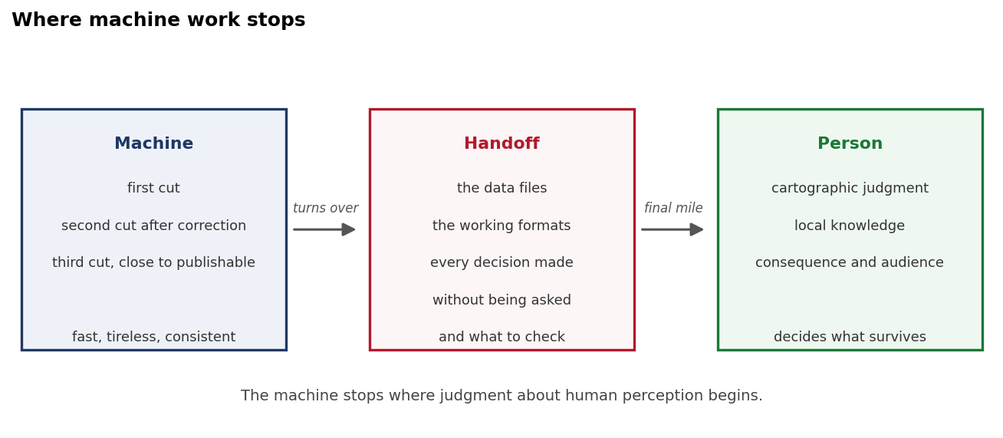
Workflow diagram. The machine takes three cuts at the analysis and turns over the data files, the working formats, every decision it made without being asked and what to check, and a person carries the result across the final mile and decides what survives.
The book makes this argument repeatedly and under several names. Section 8.14 moves from human-in-the-loop to meaningful human authority, section 15.8 puts human review, local knowledge and red teaming together as one function, and the language of human judgment appears as early as section 1.6, local knowledge enters in Chapter 2, and override becomes a working term in Chapter 8 and returns in Chapter 16. The labs give that argument something to stand on, because a student who has seen the machine make four unjustified choices in a single map understands the handoff differently from a student who has read that it matters. The handoff also gives an instructor something concrete to grade, since the questions in the decisions file have answers that are either supported by the student's own numbers or are not.
The cartography in this workbook was produced by machine and it is imperfect on purpose. Legends collide with map bodies, class counts are unjustified, and color ramps arrive as defaults that no argument supports. Those defects were left in as specimens, and several exercises ask the student to find and repair them. A reader who concludes that the maps in this collection would be better if a cartographer had drawn them has understood the point the collection is making.
Every lab built on a program of the collection's own design consequently ends with a handoff package, and the three that do not, Labs II-A, VI-A and VI-B, say what they produce in its place. The machine writes a table carrying every unit and every statistic it computed, and a second file naming each decision it made without being asked alongside the questions a human must answer before the result is published. Students submit both, and the questions in the second file are the ones the write up has to answer. Those questions were written by the same program that made the decisions, which means the list is incomplete by construction, and several exercises ask the student to add the question the machine failed to raise.

Part 0. Fundamentals and Their Failure Modes
GeoAI Risks discusses hot spot maps, interpolated surfaces and spatial aggregation as concepts and leaves the statistics behind them to its reader. A reader trained in geospatial intelligence brings that background, and the broader readership this book deserves often does not. Part 0 closes the gap by running the fundamental methods, showing what each one assumes, and demonstrating what each produces when its assumptions do not hold. The treatment stays deliberately practical, since the objective is a reader who can state what a method assumed and check whether the assumption held.
The danger the book describes throughout depends on this material. Advanced spatial statistics now arrive as a menu item in software that asks the user for a field name and nothing else, and the tool returns a confident answer whether or not the data can support one. A user who cannot state what the tool assumed cannot tell a real cluster from an artifact of the weights matrix, and the resulting map carries the same authority either way. The labs in this Part put numbers on how large that difference can be, which is the only form of the argument that survives contact with a skeptical reader.
Instructors whose students have completed a spatial statistics course may skip Part 0 entirely. Every later Part opens with a short fundamentals block naming the methods it puts in play and their failure modes, so a class that skips Part 0 still meets the assumptions of the models it uses. Nothing in Parts I through VI depends on Part 0 having been assigned. Instructors uncertain about their students should assign Lab 0-A alone, since it stands on its own and it exposes the misconception that most reliably damages later work.

Lab 0-A. Spatial Dependence Before Anything Else
Learning Objectives
Compute global Moran's I under five spatial weights schemes and compare how the verdict and the magnitude respond to the choice
Distinguish a real cluster from an artifact using fields whose answer is known in advance
Apply a false discovery correction to Getis-Ord Gi* results and quantify how many findings survive it
Interpret local Moran cluster types and state what each implies about the geography
Identify the decisions a hot spot tool makes without asking and answer them in a handoff
Required Software Tools and Setup
Python 3.11 or later with pandas, numpy, scipy and matplotlib
Install command: pip install pandas numpy scipy matplotlib
Google Colab, as an alternative for anyone who cannot install Python locally
Any artificial intelligence assistant, for the optional Tier 3 steps
Programs for this lab, all in the toolkit folder of the companion repository:
exercise_0a.py
spatial_stats.py
Lab at a Glance
Textbook sections | sections 2.3, 2.8, 4.2, 5.6.2, 8.14, 15.8, and the fundamentals behind the hot spot maps the book discusses from Chapter 4 onward
Fundamentals covered | spatial weights matrices, global Moran's I, permutation inference, local Moran's I and cluster types, Getis-Ord Gi*, multiple comparisons
Technical demand | Tier 1 and Tier 2 required, Tier 3 optional. Python with pandas, numpy, scipy and matplotlib. No GIS, no key, no account
Effort | three hours including the write up
Prerequisites | none

0-A.1 Lab 0-A Overview
A hot spot analysis answers the question of where values cluster, and it answers that question whether or not the data clusters at all. Software that presents Getis-Ord Gi* as a menu item accepts a field name, applies a default spatial weights matrix, tests every unit at the conventional threshold, and returns a map covered in red and blue polygons. Nothing in that sequence asks whether the pattern is clustered, which weights matrix suits the phenomenon, or how many of the significant units would appear by chance in data with no structure. This lab runs all three checks and reports what each one costs.
The lab works on Mississippi census tract poverty, which is genuinely clustered, and on three synthetic fields whose answers are known in advance. Synthetic data matters here because a student who only ever analyzes real data can never distinguish a method that works from a method that agrees with their expectations. A random field with no clustering in it, analyzed by the default procedure, produces significant hot spots, and seeing that happen is worth more than reading that it can. The three synthetic fields are generated in code from a stated seed, so a student can change their parameters and watch a known answer move.
Figure withheld from this edition. This figure prints values the lab asks you to find, so it appears only in the instructor edition. Your own run of the lab's program produces the numbers it summarizes.
Figure, three panels. The synthetic random, checkerboard and clustered fields rendered as lattices, with the Moran's I value printed on each.
The closing step is the handoff. The program writes every statistic it computed into a table a person can open, and writes a second file listing the eight decisions it made without being asked. The student answers the questions in that second file, which is the work the machine could not do. Answering them requires the evidence gathered in the preceding steps, so a student who skipped the parameter changes will find the final step impossible to complete honestly.
0-A.2 Lab 0-A Step-by-Step Instructions
Step 1: Run the exercise (Tier 1)
Change to the toolkit folder inside GeoAI_Exercises and type python exercise_0a.py. The program prints five blocks, writes one figure into figures and writes two handoff files into handoff. Read the printed report once before you look at the map, because the map is persuasive and the numbers are not, and reading them in that order guards against believing the picture.
Step 2: Record the weights matrix sensitivity (Tier 1)
Block 1 computes global Moran's I on the same tract poverty values under five spatial weights schemes: rook contiguity, queen contiguity, four and eight nearest neighbors, and a forty kilometer distance band. Record all five coefficients, the average neighbor count under each, and the verdict each returns. Then answer two questions in writing. Does the verdict change across the five schemes, and does the magnitude change? Those are different questions with different answers here, and conflating them is the error the step exists to catch.
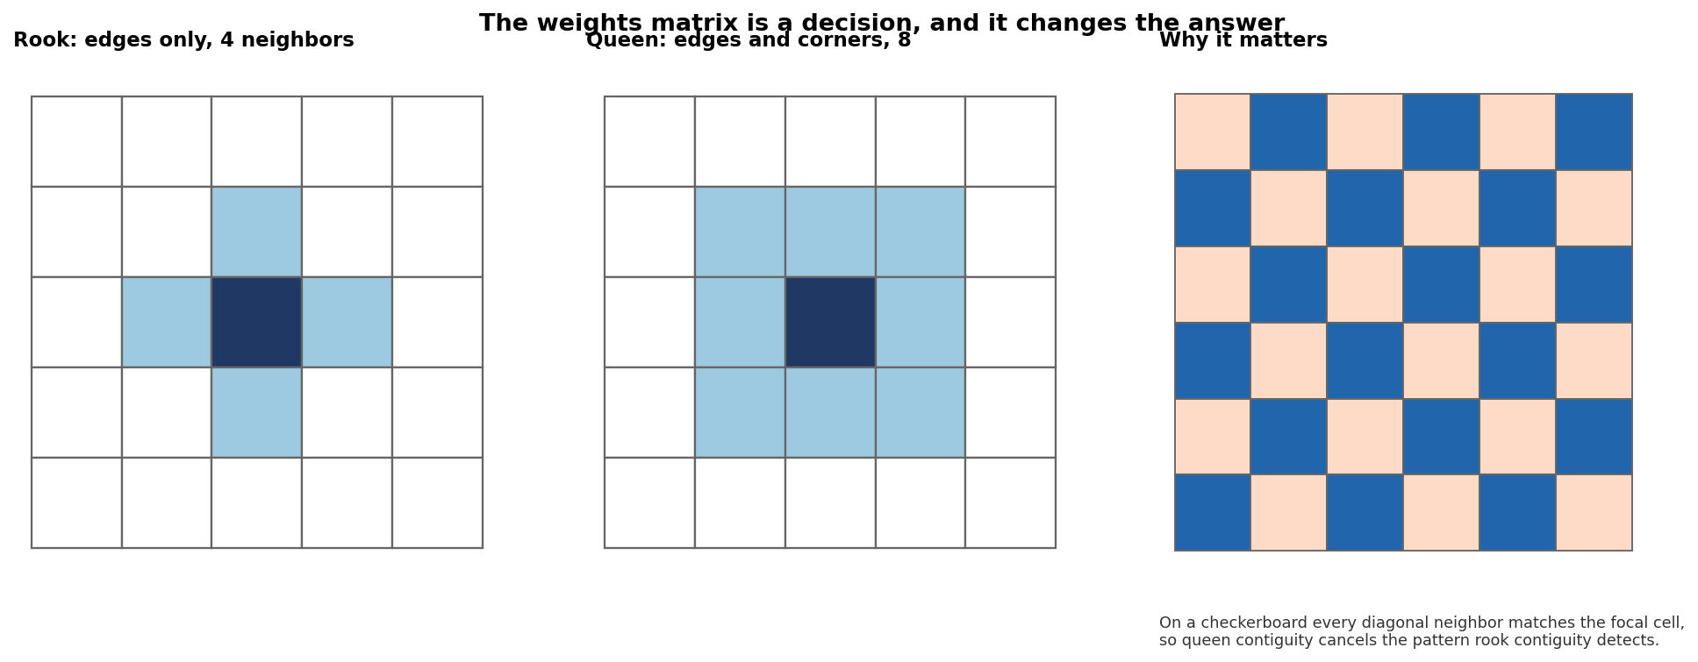
Figure. Rook against queen contiguity drawn on a small grid, showing which cells count as neighbors under each, with the checkerboard beneath so the cancellation is visible.
Step 3: Record what happens on data whose answer you know (Tier 1)
Block 2 analyzes three synthetic fields on a thirty by thirty lattice. The first is spatially independent noise, the second is a checkerboard that alternates high and low, and the third is smoothed noise carrying genuine positive autocorrelation. Record the rook and queen coefficients for each field, the count of units Gi* flags at the conventional threshold, and the count that survives a false discovery correction. The checkerboard row is the one to study, because the two weights schemes disagree about it completely and only one of them is right.
Step 4: Record the cost of the correction on real data (Tier 1)
Block 3 runs Gi* on the Mississippi tracts under queen contiguity and reports the count of significant units before and after a Benjamini-Hochberg false discovery correction. Record both counts and the difference. Then look at the second and third panels of exercise_0a_clusters.png and write one paragraph describing what a decision maker shown only the middle panel would conclude, and what the same decision maker shown only the right panel would conclude.
Step 5: Record the cluster types (Tier 1)
Block 4 reports local Moran's I cluster membership in four categories, being high values surrounded by high values, low surrounded by low, and the two mixed cases. Record all four counts and the count of tracts reaching no significance. Then explain what a high value surrounded by low values means substantively, and why a map that shows only the hot spots and hides that category is misleading about the geography.
Step 6: Change the weights and rerun (Tier 2)
Open exercise_0a.py and find the line where the Gi* and local Moran calls select Ws["queen"]. Change that to Ws["rook"], then to Ws["knn8"], rerunning after each change. Record the significant counts under all three, and state which of the three you would defend to a reviewer and why. A phenomenon that travels along roads and rivers has different neighbors from one that spreads across shared borders, and the weights matrix is where that belief gets encoded.
Step 7: Read the code (Tier 1)
The lab names one block for annotation, being the function build_weights in spatial_stats.py, and specifically the branch that builds contiguity from shared polygon vertices. Write a plain language annotation of that branch, stating what it consumes, what it produces, and what would change if the threshold need were set to 1 in place of 2. Then explain why comparing floating point coordinates for exact equality can miss neighbors, and use the average neighbor counts from Block 1 to judge whether the shipped GeoJSON preserved the shared vertices the technique needs.
Step 8: Complete the handoff (Tier 1)
Open exercise_0a_decisions.json from the handoff folder. It lists eight decisions the program made without asking you, and five questions a person must answer before the map is published. Answer all five in writing, using the evidence from Steps 2 through 6. Then add a sixth question of your own that the program failed to raise, and explain why it belongs on the list.
Step 9: Put the assistant to work (Tier 3, optional, ten points)
Open a fresh session with any assistant and give it this, with no other context.
I have a table of Mississippi census tracts with a poverty percentage.
Run a hot spot analysis and tell me where the poverty hot spots are.
Record what it produced, then record what it did not ask you. Specifically, did it choose a spatial weights matrix and tell you which one, did it test whether the pattern is clustered before looking for clusters, and did it mention multiple comparisons at all. Then write one paragraph on which of those three omissions would have been hardest for a non-specialist to notice in the delivered result.
0-A.3 Lab 0-A Key Takeaways: Spatial Dependence Before Anything Else
A hot spot analysis rests on three decisions, and commercial software supplies a default for each that runs whether or not the user ever reads it. The weights matrix encodes a belief about how the phenomenon travels, the significance threshold governs how much evidence a cluster needs, and the multiple comparison correction determines how many of the findings survive contact with the number of tests performed. A user who states none of the three has still made all three. The distinction that matters is between a decision taken deliberately and a decision inherited from a default, because only the first can be defended to a reviewer.
Global pattern tests and local cluster tests answer different questions and neither substitutes for the other. A globally random field can hold one real local cluster, so a non-significant global statistic is no absolute prohibition on local analysis. What it does is shift the burden, because a local cluster found inside a globally random field needs stronger evidence and an explanation for its existence, and the correction becomes mandatory in that setting. Students should carry that formulation into every later chapter, since the same asymmetry between global and local evidence recurs whenever a system reports local findings.
Figure withheld from this edition. This figure prints values the lab asks you to find, so it appears only in the instructor edition. Your own run of the lab's program produces the numbers it summarizes.
Local Moran cluster map beside Getis-Ord before and after a false discovery correction. The middle and right panels differ by one methodological choice.
The weights matrix can change the answer completely and the checkerboard proves it. Two schemes that both look reasonable return different verdicts on identical data, which means the analyst chose the answer at the moment they accepted a default. That result belongs beside the modifiable areal unit problem in Chapter 4, since both describe a representational decision that determines the finding while remaining invisible in the output. The two failures also compound, because an analyst who has chosen a geography has already constrained which weights matrices are even available.
Correction is not a formality. The two counts recorded in Step 4 measure how much of the apparent finding came from testing one hypothesis per tract. The uncorrected map is the one most practitioners produce and the one most decision makers see. Correcting it costs a single function call and changes nothing else in the workflow, which makes the omission difficult to defend once it has been pointed out.
0-A.4 Lab 0-A Questions
1. Compare how the verdict and the coefficient behave across the five weights schemes in Block 1, explain what you find, and state a circumstance in which the verdict would change.
2. Compare the checkerboard coefficients under rook and queen contiguity, explain the geometry that produces the difference, and state which of the two schemes you would use to detect a dispersed pattern.
3. A colleague argues that applying a false discovery correction is too conservative because it hides real clusters. Using the synthetic results in Block 2, state what the correction cost on the genuinely clustered field and what it cost on the random field, then answer the colleague.
4. Section 8.14 distinguishes human-in-the-loop from meaningful human authority, which requires authority to disagree, sufficient information, time, competence, alternative evidence and institutional protection. Using the handoff file from Step 8, state which of the eight machine decisions a person could meaningfully override in a real workflow and which would require rebuilding the analysis.
0-A.5 Lab 0-A Extra Credit
Optional, up to ten extra credit points.
The distance band scheme in Block 1 uses forty kilometers, which nobody justified. Rerun the analysis across bands from ten to one hundred kilometers in ten kilometer steps, plot the coefficient against the band width, and identify the distance at which the statistic stops changing materially. State what that distance means about the geographic scale of the process, and whether it matches the scale at which poverty policy is actually administered in Mississippi. A mismatch between the two is itself a finding, since a process operating at one scale governed by a program operating at another will produce persistent allocation errors.
0-A.6 Lab 0-A Data Package
The data package for this lab consists of 2 files, each already frozen in the snapshots folder of the companion repository and each drawn from the United States Census Bureau, which publishes without registration or a key. The snapshot carries a SHA256 checksum recorded in its manifest, and the program for this lab prints that checksum on every run so a student can confirm the data matches the data the expected values came from. Nothing in the lab touches the network once the snapshot exists, which lets the analysis reproduce offline and years after the original source has changed. The table below lists each file, what it holds and how large it is.
File | Contents | Size
acs2023_mississippi_asi.csv | American Community Survey 2023 five year estimates for Mississippi at county, tract, block group and ZCTA level | 3,832 rows
ms_tracts.geojson | Mississippi census tract boundaries, simplified and projected to EPSG:5070 | 875 polygons; the three water-only tracts in the Census table carry no boundary

Lab 0-B. The Variogram and What Its Parameters Do
Learning Objectives
Construct an empirical variogram and describe how lag distance and bin count shape it
Explain what the nugget, sill and range represent and measure how each changes cross validated error
Test for anisotropy with directional variograms and relate the result to terrain
Determine the smallest station count that supports a defensible kriged surface
Compare ordinary kriging with inverse distance weighting and interpret the kriging variance surface
Required Software Tools and Setup
Python 3.11 or later with pandas, numpy, scipy and matplotlib
Install command: pip install pandas numpy scipy matplotlib
The optional refresh program pull_azmet.py also needs the lxml library: pip install lxml
Google Colab, as an alternative for anyone who cannot install Python locally
Any artificial intelligence assistant, for the optional Tier 3 steps
Programs for this lab, all in the toolkit folder of the companion repository:
exercise_0b.py
kriging.py
common.py
pull_azmet.py, optional, replaces the frozen station snapshot with a fresh download
Lab at a Glance
Textbook sections | the interpolation fundamentals behind sections 10.3, 10.4, 11.12 and 15.7
Fundamentals covered | inverse distance weighting, the empirical variogram, model fitting, ordinary kriging, kriging variance, leave one out cross validation
Technical demand | Tier 1 and Tier 2 required. Python with numpy, scipy, pandas and matplotlib
Effort | three hours including the write up
Prerequisites | none, though Lab 0-A introduces the weights idea this lab extends

0-B.1 Lab 0-B Overview
Interpolation turns a scatter of measured points into a continuous surface, and every pixel in that surface is a claim about a place nobody measured. Inverse distance weighting makes that claim from distance alone and asks the analyst for one parameter. Ordinary kriging makes it from a fitted model of how the phenomenon varies with separation, and asks the analyst for five or six. The extra parameters are the reason kriging is better and the reason it fails more interestingly, because each one encodes a belief about the phenomenon that the software will accept without argument.
The lab interpolates mean annual air temperature across the Arizona Meteorological Network, a set of stations spread across a state with pronounced relief. Students fit an empirical variogram, watch what the lag distance and bin count do to its shape, fit a model, and then move the nugget, the sill and the range one at a time while cross validated error reports the consequence. Anisotropy enters last, because temperature in Arizona varies with elevation and elevation is not isotropic, so a model that assumes the same behavior in every direction is making a claim the terrain contradicts. Each of those parameters is presented by commercial software as a field with a default already in it.
Every parameter change produces a map and an error figure, and the student reports both. A surface that looks smoother is not therefore better, and separating the two is the skill the lab builds.
0-B.2 Lab 0-B Step-by-Step Instructions
Step 1: Run against the frozen station year and see the points (Tier 1)
Change to the toolkit folder inside GeoAI_Exercises and type python exercise_0b.py to run the lab against the frozen station year in snapshots. Running python pull_azmet.py replaces the frozen snapshot with a fresh download and changes the checksum, so run it only when your instructor asks. Record the station count, the elevation range and the checksum on your provenance card. The network map below shows the stations as plain points, and you should look at it before any surface exists, because the sampling design constrains everything that follows and the gaps in the network are where the interpolation will be least trustworthy.
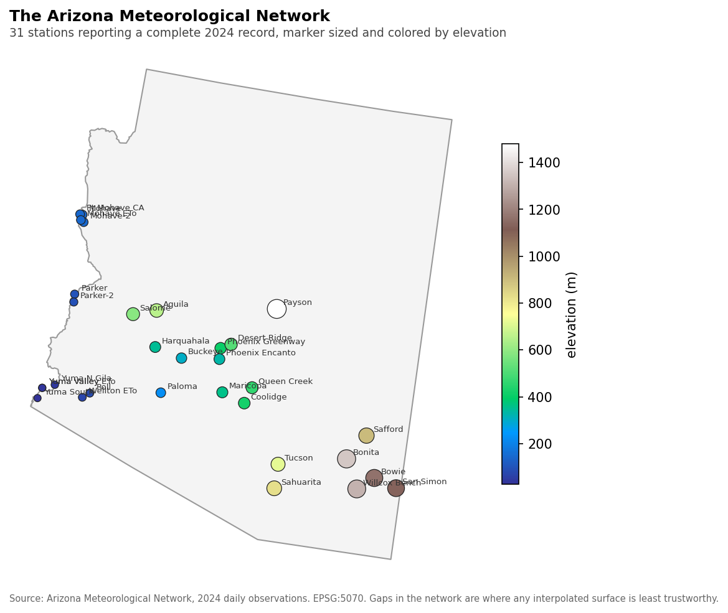
Map. The station network as points over the state outline, each marker sized and colored by elevation, with the gaps in coverage visible.
Step 2: Build the empirical variogram (Tier 1)
The program computes semivariance for every station pair, bins those pairs by separation distance, and plots the binned means against distance. Record the number of pairs, the lag distance the program chose, and the bin count. Then read the shape of the cloud and answer in writing whether semivariance rises with distance, where it stops rising, and what the value at very short separations appears to be.
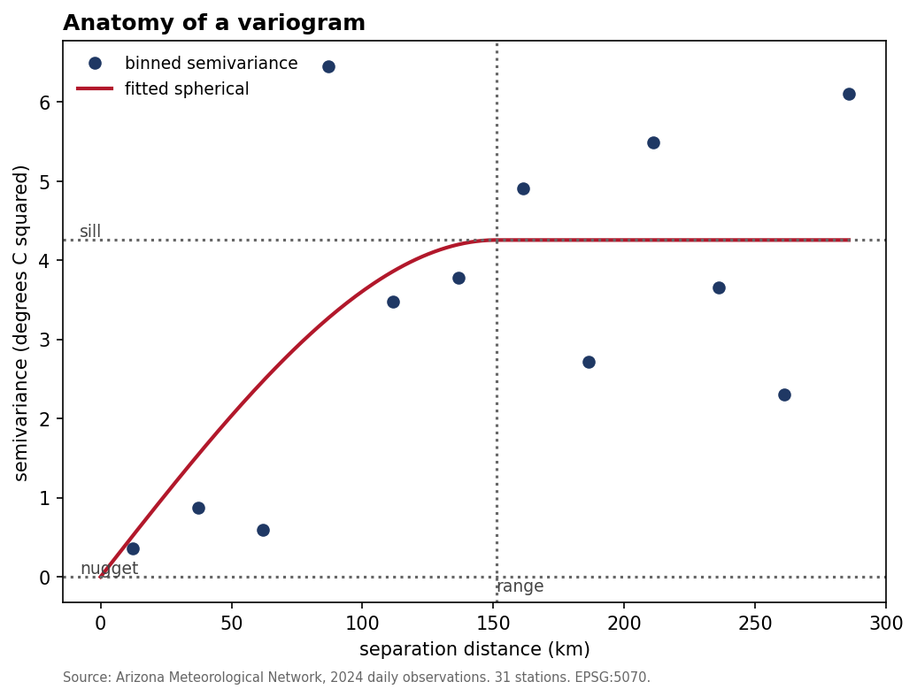
Figure. Anatomy of a variogram, with nugget, sill and range labeled on a fitted curve over a binned empirical cloud.
Step 3: Move the lag (Tier 2)
Block 3 refits the variogram at each lag distance listed in LAG_SWEEP at the top of exercise_0b.py and skips any lag that leaves fewer than three bins. Record the bin count, fitted range, sill and cross validated error at each lag it fits, and name any lag it skipped. Then add a lag of your own choosing to LAG_SWEEP, rerun, and record the result. Lag choice is a smoothing decision on the variogram itself, so too few wide bins hide structure and too many narrow bins produce a cloud too noisy to fit, and finding the middle is a judgment the software will not make.
Figure withheld from this edition. This figure prints values the lab asks you to find, so it appears only in the instructor edition. Your own run of the lab's program produces the numbers it summarizes.
Figure, three panels. The same empirical variogram binned at three lag distances, showing structure hidden by wide bins and noise created by narrow ones.
Step 4: Move the nugget and the range (Tier 2)
The program fits a spherical model and reports the nugget, the sill and the range. Block 4 then refits with one parameter held at an alternative value at a time, being the nugget at zero, the nugget at 99.9 percent of the sill, the range halved and the range doubled, and reports the leave one out cross validated root mean square error under each. Record all four errors, then change one of the alternative values in the overrides list in exercise_0b.py, rerun, and record the result. State in writing what the nugget represents physically, and why a nugget that equals the sill produces a surface that is indistinguishable from the global mean.
Step 5: Test for direction (Tier 2)
The program attempts directional variograms in the four bearings listed in DIRECTIONS and reports any bearing with too few pairs to fit. Record the fitted range and sill for each bearing it fits, name the bearing it could not fit, then state whether the network shows anisotropy and in which orientation. Arizona's relief runs in a recognizable direction and temperature follows elevation, so an anisotropy finding here has a physical explanation the student should name.
Figure withheld from this edition. This figure prints values the lab asks you to find, so it appears only in the instructor edition. Your own run of the lab's program produces the numbers it summarizes.
Figure. Directional variograms for the bearings the program could fit, drawn on one axis, with the fitted range annotated per bearing.
Step 6: Drop stations and watch it degrade (Tier 2)
The program refits the variogram using random subsets of the network at several sample sizes, reporting cross validated error at each. Record the error at every sample size and identify the point below which the variogram can no longer be fitted with confidence. State how many stations you would require before you would publish a kriged surface of this variable, and defend the number.
Step 7: Compare against inverse distance weighting (Tier 1)
The program produces both surfaces from identical points and reports cross validated error for each. Record both errors and both maps. Then answer the question the comparison raises: kriging also produces a variance surface and inverse distance weighting produces nothing of the kind, so state what that variance surface tells a decision maker that the prediction surface alone cannot.
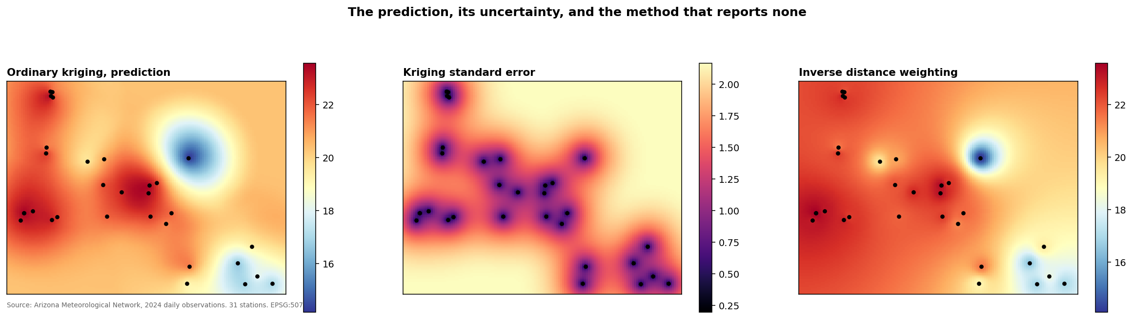
Map, three panels. The kriged prediction surface, its standard error surface and the inverse distance weighted surface on a shared extent, with station locations overlaid on each.
Step 8: Read the code (Tier 1)
Annotate the function fit_variogram in kriging.py, stating what it consumes, what it produces, and what would change if the model form were switched from spherical to exponential. Then explain why the fitting is performed on binned means and never on the raw pair cloud.
Step 9: Complete the handoff (Tier 1)
Open the decisions file the program writes and answer every question in it. The list includes the model form, the lag, the search neighborhood and the color treatment of the variance surface, none of which the program justified.
0-B.3 Lab 0-B Key Takeaways: The Variogram and What Its Parameters Do
A kriged surface is a model output and the parameters are the model. Nugget, sill, range and anisotropy each encode a belief about how the phenomenon behaves in space, and a surface produced from defaults encodes the software author's beliefs in place of the analyst's. Cross validated error is the only honest referee among competing parameter sets, because smoothness is a property of the picture and accuracy is a property of the prediction. A smoother surface invites preference on first inspection, which is why the lab reports both quantities side by side at every parameter change.
Sample size governs what can be fitted at all. A variogram estimated from too few pairs produces a range and a sill with wide uncertainty, and a surface built on that fit carries uncertainty the map never displays. The lab puts a number on where that boundary sits for this network. That number belongs in any report built on an interpolated surface, and it almost never appears in one.
The kriging variance surface is the deliverable most practitioners discard. It states where the surface is guessing, it is available at no additional cost, and a decision made from the prediction surface alone throws away the one product that would have flagged the weak areas.
0-B.4 Lab 0-B Questions
1. Explain what a pure nugget model means physically and what it implies about the sampling design that produced it.
2. Your directional variograms disagree. State two competing explanations, one about the phenomenon and one about the sampling, and name the evidence that would separate them.
3. A colleague reports that kriging produced a smoother map than inverse distance weighting and concludes it is more accurate. Using your Step 7 numbers, answer the colleague.
4. Section 15.7 asks that uncertainty be made visible. Describe the map you would publish for a decision maker who needs the temperature surface, and state where the variance surface appears in it.
0-B.5 Lab 0-B Data Package
The data package for this lab consists of 1 file, each already frozen in the snapshots folder of the companion repository and each drawn from the Arizona Meteorological Network, which publishes without registration or a key. The snapshot carries a SHA256 checksum recorded in its manifest, and the program for this lab prints that checksum on every run so a student can confirm the data matches the data the expected values came from. Nothing in the lab touches the network once the snapshot exists, which lets the analysis reproduce offline and years after the original source has changed. The table below lists each file, what it holds and how large it is.
File | Contents | Size
azmet_2024_annual.csv | Arizona Meteorological Network 2024 station summaries with elevation and coordinates | 31 stations

Lab 0-C. Regression Kriging and What a Covariate Buys
Learning Objectives
Estimate a temperature lapse rate from station data and explain its departure from the standard atmospheric value
Compare ordinary kriging, a trend on elevation and regression kriging by cross validated error
Explain why a covariate helps only where it is known more densely than the target
Measure how error in a covariate erodes an interpolation
Required Software Tools and Setup
Python 3.11 or later with pandas, numpy, scipy and matplotlib
Install command: pip install pandas numpy scipy matplotlib
Google Colab, as an alternative for anyone who cannot install Python locally
Any artificial intelligence assistant, for the optional Tier 3 steps
Programs for this lab, all in the toolkit folder of the companion repository:
exercise_0c.py
kriging.py
common.py
Lab at a Glance
Textbook sections | the multivariate interpolation fundamentals behind sections 10.4, 13.2 and 15.6
Fundamentals covered | the relationship between a target and a covariate, trend estimation, residual variograms, regression kriging, held out validation
Technical demand | Tier 1 and Tier 2 required. Python with numpy, scipy, pandas and matplotlib
Effort | two to three hours including the write up
Prerequisites | Lab 0-B

0-C.1 Lab 0-C Overview
Temperature falls with elevation, and across the Arizona network that relationship is strong enough to carry an interpolation. Regression kriging exploits such a relationship by fitting a trend on a secondary variable and kriging what the trend leaves behind, and co-kriging pursues the same goal through a joint model of the two variables. Either method improves the surface between stations only under one condition, and the condition is that the secondary variable be known where the primary is not. Software presents co-kriging without stating that condition anywhere in its interface.
Students first establish the relationship, fitting mean annual temperature on station elevation and reporting the lapse rate, the correlation and the cross validated error. They then predict temperature three ways from identical points, being ordinary kriging on temperature alone, a linear trend on station elevation with no kriging, and regression kriging, which kriges the residuals from that trend. The program has no terrain grid, so off the stations it interpolates elevation from the same 31 stations, and the lab asks what that choice does to the surface between stations. Students who predict the outcome before running it, and record their prediction, learn more from the result than students who read it off the report.
0-C.2 Lab 0-C Step-by-Step Instructions
Step 1: Establish the relationship (Tier 1)
Change to the toolkit folder inside GeoAI_Exercises and type python exercise_0c.py. The program fits temperature on elevation and reports the slope as a lapse rate in degrees per thousand meters, the intercept, the correlation, r squared, and the root mean square and mean absolute leave one out cross validated errors. Record all six. Then compare the observed lapse rate against the standard atmospheric value near 6.5 degrees per thousand meters and explain the direction of the difference, which has a real physical answer involving surface heating and the elevation distribution of the network.
Step 2: Predict three ways (Tier 1)
Record the cross validated error under ordinary kriging, under the trend on elevation alone, and under regression kriging. Record the two surfaces the program maps and the difference between them. State which methods improved on ordinary kriging and by how much, and what share of the regression kriging gain the trend alone delivers.
Step 3: Explain the result (Tier 1)
Cross validation predicts each station from the others. State where elevation is known when the program predicts a held out station, explain why the trend and the regression kriging improve cross validated error there, and state what the surface between stations can gain when elevation there comes from the same 31 points. Section 13.2 defines a proxy as a measure used where the target is difficult or impossible to observe directly at the required scale, frequency or cost, and Table 13.2.1 classes elevation as a mechanistic proxy, so the chapter's definition already carries the condition this step asks about.
Figure withheld from this edition. This figure prints values the lab asks you to find, so it appears only in the instructor edition. Your own run of the lab's program produces the numbers it summarizes.
Map, three panels. The ordinary kriging surface and the regression kriging surface, each titled with its cross validated error, and the difference between them.
Step 4: Break the covariate (Tier 2)
Block 4 degrades the elevation covariate by adding noise at each level listed in NOISE_LEVELS at the top of exercise_0c.py and reruns the regression kriging at each level. Record the cross validated error against the noise level and identify the point at which the covariate stops helping. Then add a noise level of your own between the last level that helps and the first that does not, rerun, and refine the estimate. State what that implies about using a modeled or remotely sensed covariate whose own error is unreported.
Step 5: Read the code (Tier 1)
Annotate the branch of ordinary_kriging in kriging.py that handles the secondary argument, stating what it consumes, what it produces, and why it needs the covariate at every prediction site.
Step 6: Complete the handoff (Tier 1)
Answer the questions in the decisions file, which include the search neighborhood, the treatment of stations outside the state boundary, and whether the prediction grid resolution was ever justified.
0-C.3 Lab 0-C Key Takeaways: Regression Kriging and What a Covariate Buys
A covariate helps an interpolation when it is known where the target is unknown. Where the two are sampled at identical locations, the covariate is already implicit in the primary observations and the mathematics has little left to exploit. Practitioners frequently report co-kriging as an improvement without checking which of those two situations they are in.
Covariate error propagates into the surface and usually goes unreported. A terrain model, a satellite derived index or a modeled output all carry their own uncertainty, and a workflow that treats them as exact transfers that uncertainty into the prediction with no accounting anywhere.
0-C.4 Lab 0-C Data Package
The data package for this lab consists of 1 file, each already frozen in the snapshots folder of the companion repository and each drawn from the Arizona Meteorological Network, which publishes without registration or a key. The snapshot carries a SHA256 checksum recorded in its manifest, and the program for this lab prints that checksum on every run so a student can confirm the data matches the data the expected values came from. Nothing in the lab touches the network once the snapshot exists, which lets the analysis reproduce offline and years after the original source has changed. The table below lists each file, what it holds and how large it is.
File | Contents | Size
azmet_2024_annual.csv | Arizona Meteorological Network 2024 station summaries with elevation and coordinates | 31 stations

Part I. Foundations of GeoAI Risks
Chapters 1, 2 and 3 establish what a GeoAI system is, where uncertainty enters it, and how a foundational vulnerability turns into an operational failure. Chapter 1 develops spatial decision infrastructure and the points at which uncertainty enters, Chapter 2 catalogs the foundational vulnerabilities and shows how they interact, and Chapter 3 works one central case, the apparent rise in natural disasters, and shows that a recorded trend can carry hazard, exposure, vulnerability, observation and classification change at once, which leaves the analyst to separate a change in the world from a change in what observes it.
Two exercises serve this Part. Lab I-A traces uncertainty through one pipeline and demonstrates the ecological fallacy on real data. Lab I-B carries Chapter 3's central case, the apparent rise in natural disasters, to the United States tornado record, which the book does not discuss, and separates a change in the world from a change in what was watching it. Instructors with one laboratory session available should assign I-A, which introduces the aggregation ideas that Part II then develops in full.
Fundamentals in play. These labs use one correlation computed at more than one level of aggregation, the difference between a count and a rate, and normalization by an exposure denominator. Each fails in a known way. A correlation among groups supports no claim about a household, and a rate inherits every defect of its denominator.

Lab I-A. Where Uncertainty Enters, and the Fallacy That Follows
Learning Objectives
Trace the stages at which uncertainty enters a census based decision pipeline
Measure how one relationship changes between county and block group level, and explain why neither figure describes a household
Identify counties whose internal relationship runs opposite to the between-county pattern
Explain which claims a group level statistic can and cannot support about a household
Required Software Tools and Setup
Python 3.11 or later with pandas, numpy, scipy and matplotlib
Install command: pip install pandas numpy scipy matplotlib
Google Colab, as an alternative for anyone who cannot install Python locally
Any artificial intelligence assistant, for the optional Tier 3 steps
Programs for this lab, all in the toolkit folder of the companion repository:
exercise_1a.py
common.py
mapping.py
Lab at a Glance
Textbook sections | sections 1.4, 1.5, 1.6, 2.2, 2.7, 2.8
Fundamentals covered | inference across levels of aggregation, correlation at group and unit level, uncertainty entry points
Technical demand | Tier 1 and Tier 2 required, Tier 3 optional. Python with pandas, numpy and matplotlib
Effort | two to three hours including the write up
Prerequisites | none

I-A.1 Lab I-A Overview
Section 1.4 identifies six forms of uncertainty along the GeoAI decision chain, being observation, data, representational, model, interpretive and decision uncertainty. Section 2.2 then works the ecological fallacy, in which a relationship observed among groups gets applied to the individuals inside them. This lab makes both concrete on one dataset the student can hold in view.
Students trace a single pipeline from a Census survey response through the published estimate, the geographic unit, the derived index and the resulting ranking, tagging what enters at each stage and what the next stage can no longer recover. They then compute one relationship at county level and at block group level and report how far apart the two answers sit. The gap measures the scale effect of section 2.3, and the lab then asks what claim about a person either figure would support, the question on which the ecological fallacy of section 2.2 turns. Section 2.7 then shows how these vulnerabilities interact, and the lab closes by asking the student to name one such interaction from their own results.
I-A.2 Lab I-A Step-by-Step Instructions
Step 1: Trace the pipeline (Tier 1)
Change to the toolkit folder inside GeoAI_Exercises and type python exercise_1a.py. The program prints the six stages the Mississippi data passes through, from survey response to published ranking, with what happens and what uncertainty enters at each. Record the six stages and name, for each one, one kind of uncertainty that enters there, the form of uncertainty from section 1.4 it belongs to, and one thing the following stage can no longer recover.
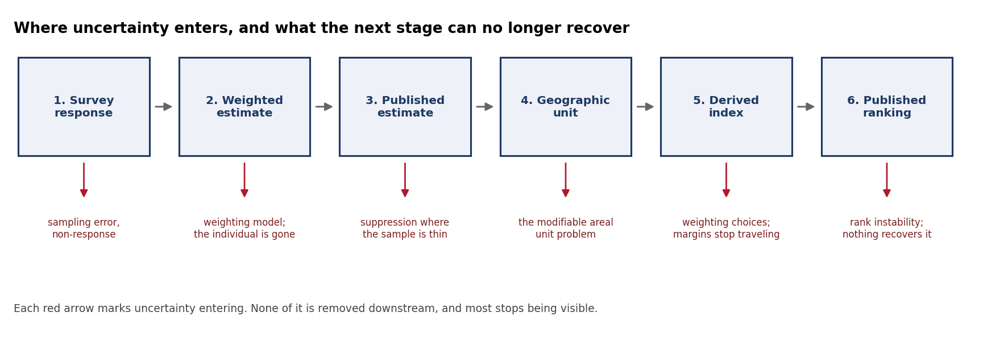
Diagram. The six stage pipeline from survey response to published ranking, with the uncertainty entering at each stage marked beneath it.
Step 2: Measure the scale effect (Tier 1)
Record the correlation between poverty and the share of households without a vehicle at county level and at block group level, then state the relationship each supports. Write the sentence a journalist would write from the county figure, then write the sentence the block group figure supports, and state what neither supports about any individual household.
Step 3: Find the reversal (Tier 1)
The program lists counties in which the relationship among that county's own block groups runs opposite to the between-county relationship. Record how many counties show that reversal and give the county codes of three. Section 3.9 notes that a pattern observed at one scale may disappear or reverse at another, and this step looks for that reversal inside Mississippi counties. State whether any within-county correlation is large enough to distinguish from zero for its number of block groups.
Step 4: Change the minimum (Tier 2)
Open exercise_1a.py and change MIN_BG at the top of the file from 8 to 12 and then to 20, rerunning after each change. Record how the number of counties tested and the number of reversals change, and state what that sensitivity says about the reversal count as evidence.
Step 5: Map it (Tier 1)
The program maps the county level result beside the tract level result. Record both maps and state which one a decision maker would find more persuasive, then state which one is more likely to be right about a household, and explain why those two answers differ.
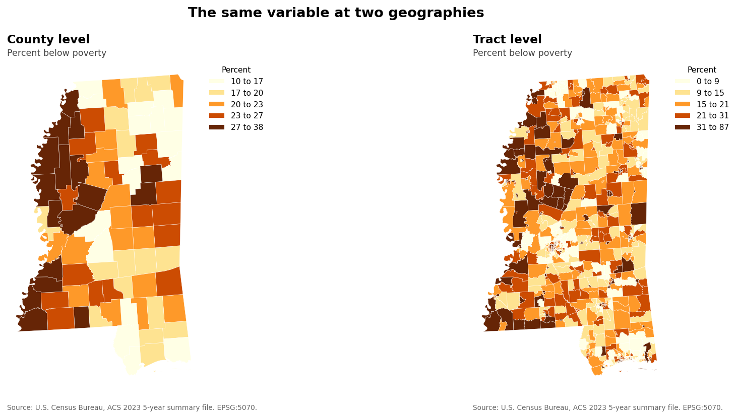
Map pair. Percent below poverty at county level beside the same variable at tract level, in the same color ramp with quantile classes, so the variation the county figure averages away becomes visible on the page.
Step 6: Name an interaction (Tier 1)
Name one way the scale effect you measured in Step 2 could combine with another foundational vulnerability from section 2.7 in a decision built on these data, and cite the numbers that make it plausible.
Step 7: Read the code and complete the handoff (Tier 1)
Annotate the block that computes the relationship at each geography and the block that tests each county for a reversal, and answer the questions in the decisions file.
Step 8: Ask the assistant (Tier 3, optional, ten points)
Give an assistant the county table with the single instruction to describe the relationship between poverty and households without a vehicle in Mississippi, and record whether it warned you about inference to individuals without being asked.
I-A.3 Lab I-A Data Package
The data package for this lab consists of 3 files, each already frozen in the snapshots folder of the companion repository and each drawn from the United States Census Bureau, which publishes without registration or a key. The snapshot carries a SHA256 checksum recorded in its manifest, and the program for this lab prints that checksum on every run so a student can confirm the data matches the data the expected values came from. Nothing in the lab touches the network once the snapshot exists, which lets the analysis reproduce offline and years after the original source has changed. The table below lists each file, what it holds and how large it is.
File | Contents | Size
acs2023_mississippi_asi.csv | American Community Survey 2023 five year estimates for Mississippi at county, tract, block group and ZCTA level | 3,832 rows
ms_tracts.geojson | Mississippi census tract boundaries, simplified and projected to EPSG:5070 | 875 polygons; the three water-only tracts in the Census table carry no boundary
ms_counties.geojson | Mississippi county boundaries, projected to EPSG:5070 | 82 polygons

Lab I-B. Signal, or a Change in What Was Watching
Learning Objectives
Separate a change in the observing system from a change in the hazard using the tornado record
Compare raw counts, intensity restricted counts and exposure normalized rates
Evaluate a documented detection change as an explanation for an apparent trend
State the limits of what a count based analysis can determine
Required Software Tools and Setup
Python 3.11 or later with pandas, numpy, scipy and matplotlib
Install command: pip install pandas numpy scipy matplotlib
Google Colab, as an alternative for anyone who cannot install Python locally
Any artificial intelligence assistant, for the optional Tier 3 steps
Programs for this lab, all in the toolkit folder of the companion repository:
exercise_1b.py
common.py
Lab at a Glance
Textbook sections | sections 3.2, 3.3, 3.7, 3.9, 3.11
Fundamentals covered | denominators, exposure normalization, detection regimes, change point reasoning
Technical demand | Tier 1 and Tier 2 required. Python with pandas, numpy and matplotlib
Effort | three hours including the write up and the reading
Prerequisites | none

I-B.1 Lab I-B Overview
Section 3.2 argues that more data can look like more disasters, and the United States tornado record is the cleanest available demonstration because the observing system changed on a documented schedule. Reports rise steeply across the period of record, the population exposed to being a witness rose across the same period, and a national radar network was deployed through the 1990s. This lab separates those contributions as far as the data allows and states plainly where separation stops being possible. That last clause is the part students omit, and it is the part a reviewer will test first.
None of the analysis here tests whether hazards have intensified, and the program repeats that statement on screen and in its figure. What it tests is whether a count can be read as a rate, which is a question about denominators and detection, and it applies two of the nine techniques in the Signal-versus-Symptom Analytic Toolkit of section 3.9 (Table 3.9.1), normalization and the detection audit.
I-B.2 Lab I-B Step-by-Step Instructions
Step 1: Plot the raw count (Tier 1)
Change to the toolkit folder inside GeoAI_Exercises and type python exercise_1b.py. Record the annual report totals and describe the trend in one sentence. This is the figure that circulates and the lab begins there deliberately.
Step 2: Restrict to the stronger events (Tier 1)
Record annual counts restricted to the higher intensity categories. These depend less on detection, since strong tornadoes usually leave surveyed damage, but they depend on how damage was rated, and the rating scale changed from the Fujita to the Enhanced Fujita scale in 2007. State how the restricted series differs from the raw series.
Step 3: Normalize by exposure (Tier 1)
The program computes a rate per million residents when a national population series is present in snapshots, and it reports the rate panel as unavailable when none is present. Record the rate where the program reports one. State in either case what a population denominator does and does not control for, and name the population series you would use.
Step 4: Mark the detection change (Tier 1)
The program marks the radar deployment window on every panel. State whether the raw series changes behavior across that window and whether the intensity restricted series does.
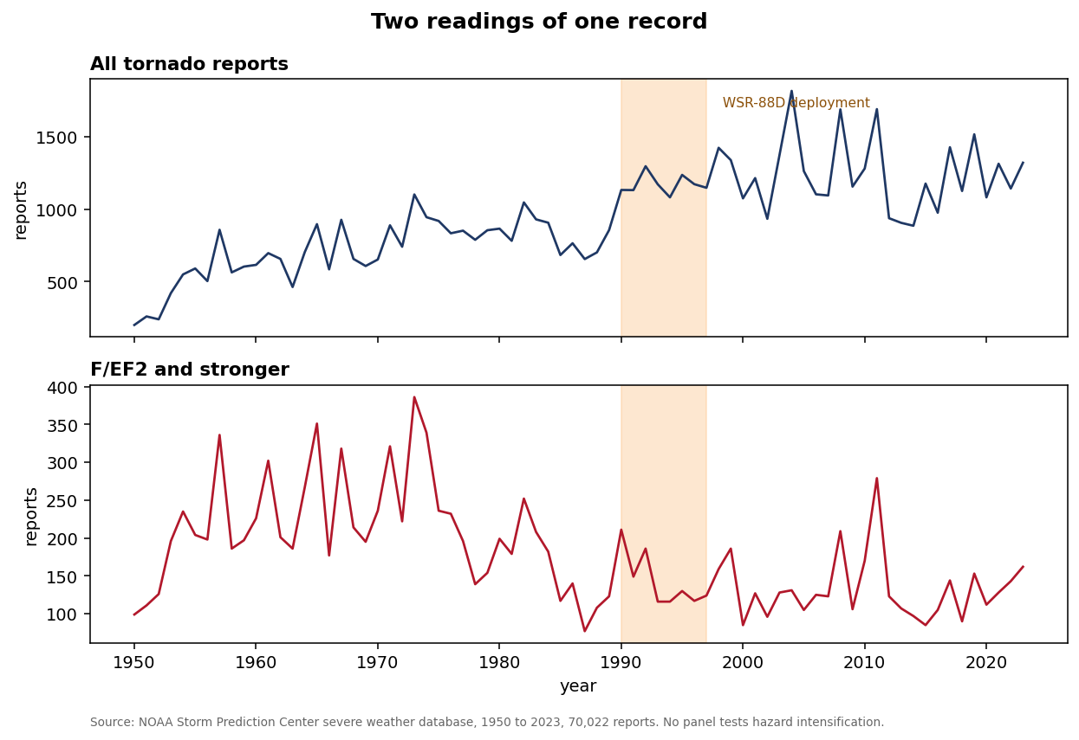
Figure, stacked panels sharing a time axis. Raw annual counts and counts restricted to F/EF2 and stronger, with the WSR-88D deployment window shaded on each, and a panel of counts per million residents added when the program has a population series.
Step 5: Move the intensity threshold (Tier 2)
Change STRONG at the top of exercise_1b.py from 2 to 3, rerun, and record how the restricted series and the comparison across the radar window change. State whether the pattern from Step 2 depends on where the threshold sits.
Step 6: State the limits (Tier 1)
Write one paragraph naming what this analysis cannot determine, and explain why the intensity restricted series is better evidence about the hazard while remaining imperfect evidence.
Step 7: Read the code and complete the handoff (Tier 1)
Annotate the function that supplies the denominator and answer the decisions file.
I-B.3 Lab I-B Data Package
The data package for this lab consists of 1 file, each already frozen in the snapshots folder of the companion repository and each drawn from the NOAA Storm Prediction Center, which publishes without registration or a key. The snapshot carries a SHA256 checksum recorded in its manifest, and the program for this lab prints that checksum on every run so a student can confirm the data matches the data the expected values came from. Nothing in the lab touches the network once the snapshot exists, which lets the analysis reproduce offline and years after the original source has changed. The table below lists each file, what it holds and how large it is.
File | Contents | Size
spc_tornadoes_1950_2023.csv | NOAA Storm Prediction Center tornado reports, 1950 to 2023 | 70,022 reports

Part II. Representational Risk: Aggregation and Boundary Distortion
Chapters 4, 5 and 6 develop one argument through three lenses. Chapter 4 establishes the modifiable areal unit problem and suggests an Aggregation Sensitivity Index. Chapter 5 extends the argument to zones of confusion, where several spatial frameworks assign one place conflicting, unstable or misleading meanings, and traces how those conflicts reach funding, enforcement and other decisions. Chapter 6 adds scale sensitivity and boundary effects, and supplies the diagnostic pipeline in section 6.7. Chapters 4, 5 and 6 share three tests, being multiscale validation, boundary perturbation and cross-boundary or cross-zonal transfer, and Chapters 5 and 6 each add a fourth test that follows change over time, temporal boundary auditing in section 5.6.4 and spatial drift monitoring in section 6.7.4. The three shared tests let one exercise carry the Part.
Two exercises serve this Part. Lab II-A runs three of the four tests in the diagnostic pipeline section 6.7 proposes, leaves the temporal stage to the optional Challenge, and computes an Aggregation Sensitivity Index. Lab II-B hands the student a completed analysis containing a defect and asks the student to find it. Both use the same frozen data and the same toolkit, so an instructor may assign either without additional setup, or assign II-B as a follow up to II-A in a course with the laboratory hours to spend.
Fundamentals in play. These labs use Pearson correlation at several levels of aggregation, random repartitioning as a reference distribution, percentile ranking and linear rescaling as ways of putting variables on a common scale, Jaccard overlap between ranked sets, and the coefficient of variation computed from a published margin of error. Each fails in a known way. A correlation belongs to the units that carry it, a random partition answers only the question its randomization poses, a rank hides the size of the gap between neighbors, and a median cannot be averaged into a larger unit's median.

Lab II-A. Measuring Aggregation Sensitivity
Learning Objectives
Apply multiscale validation, boundary perturbation and cross-zonal transfer to one relationship
Compute an Aggregation Sensitivity Index and defend the weighting of its components
Measure rank-order stability across geographies and standardization choices
Distinguish evidence resolution from output resolution using published margins of error
Explain why real administrative boundaries behave differently from random zones
Required Software Tools and Setup
Python 3.11 or later with pandas, numpy, scipy and matplotlib
Install command: pip install pandas numpy scipy matplotlib
Google Colab, as an alternative for anyone who cannot install Python locally
Any artificial intelligence assistant, for the optional Tier 3 steps
Programs for this lab, all in the toolkit folder of the companion repository:
asi_toolkit.py
classification_demo.py, optional, draws the four classifications figure
mapping.py, used by classification_demo.py
Lab at a Glance
Textbook sections | sections 4.2, 4.4, 4.5, 5.6.1, 5.6.2, 5.6.3, 5.6.4, 5.6.5, 6.7.1, 6.7.2, 6.7.3, 6.7.5
Technical demand | Tier 1 and Tier 2 required, Tier 3 optional. Python with pandas and numpy. No GIS, no key, no account
Effort | three hours including the write up
Prerequisites | none

II-A.1 Lab II-A Overview
Chapter 4 argues that recognizing the modifiable areal unit problem accomplishes nothing by itself, and that analysts need methods for determining whether conclusions survive a change in geographic representation. Section 4.4 names three such methods, being multiscale modeling, boundary perturbation testing and cross-boundary validation, and then suggests an Aggregation Sensitivity Index that would summarize the results into a single reported figure. The chapter states plainly that no universally accepted operational standard exists for deciding how much aggregation sensitivity is acceptable, and it leaves that question as an important research frontier. This lab takes the chapter at its word and builds one.
The analysis asks whether poverty and household vehicle access are related in Mississippi, which sounds like a question with an answer. The student measures whether the answer depends on the geography chosen to ask it, whether the published administrative boundaries produce a different relationship than random boundaries at the same resolution, and whether an independently defined partition preserves the relationship. Those three questions correspond to the three tests section 4.4 names.
The lab closes by computing an Aggregation Sensitivity Index from four components and asking the student to defend the weighting. The index has no universal threshold of acceptability, as section 4.4 states, which makes the defense the assessment. A student who reports the number without arguing for the construction has completed the arithmetic and missed the lab.
Before You Begin
You need Python installed, along with the pandas and numpy libraries. If you have never installed a Python library, open a terminal and type pip install pandas numpy and wait for it to finish. If you cannot install Python on your machine, open Google Colab in a browser, create a new notebook, and everything below works unchanged.
You need the file asi_toolkit.py from the companion repository. Name a folder GeoAI_Exercises, create a folder named toolkit inside it, and place asi_toolkit.py in toolkit. The program writes its snapshots folder beside toolkit, so everything the lab produces lands inside GeoAI_Exercises.
You need no Census key, no ArcGIS account, no GIS software and no shapefile. The data arrives as plain text tables from a public United States Census Bureau address that requires no registration. That address serves the same American Community Survey estimates the Census application programming interface returns, and it publishes the margin of error in the column adjacent to every estimate. Students who later want the programming interface will find it documented in the companion repository, and nothing in this lab depends on it.
II-A.2 Lab II-A Step-by-Step Instructions
Step 1: Freeze the data (Tier 1)
Open a terminal, change to the toolkit folder inside GeoAI_Exercises, and type python asi_toolkit.py --pull. The program downloads four American Community Survey tables from the Census Bureau summary file service, keeps only the Mississippi rows and only the columns this lab needs, and writes a single file named acs2023_mississippi_asi.csv into a snapshots folder it creates. It then prints the row count and the full 64 character SHA256 checksum, and writes both into manifest.json. Copy the row count and the checksum onto your provenance card now, along with today's date. Every later step reads the frozen file and never touches the network, so your analysis reproduces even if the Census Bureau changes something tomorrow. That practice carries the versioning discipline of section 6.8.5 from boundary layers to the data themselves, and it is also the reason your numbers and your classmate's numbers can be compared at all.
Step 2: Run the five diagnostics (Tier 1)
Type python asi_toolkit.py --report. The program prints a report with five numbered blocks and a summary. Read it once without analyzing it, then read it again with the book open to sections 4.4 and 4.5, because each block names the book sections it implements.
Step 3: Record the multiscale result (Tier 1)
Block 1 reports the correlation between the percentage of people below poverty and the percentage of households with no vehicle, computed at block group, tract and county. Record all three coefficients, the three sample sizes and the three values of r squared in a table. The coefficient changes as the geography coarsens, and the direction of that change is the scale effect Gehlke and Biehl first reported in 1934. State in one sentence what happens to the apparent strength of the relationship as the units get larger, and state in a second sentence what a decision maker reading only the county figure would conclude that a decision maker reading only the block group figure would not.
Step 4: Record the boundary perturbation result (Tier 1)
Block 2 assigns block groups at random to as many zone labels as the Census table has tract rows, 878, five hundred times, recomputing the correlation under each partition, so some labels receive no block group in a given draw. Record the fifth percentile, the median and the ninety fifth percentile of that distribution, and record where the real tract value falls within it.
Figure withheld from this edition. This figure prints values the lab asks you to find, so it appears only in the instructor edition. Your own run of the lab's program produces the numbers it summarizes.
Figure. Histogram of the correlation across five hundred random partitions, with the observed tract value marked as a vertical line. This is the test section 5.6.2 calls a spatial stress test. Answer the question it raises: if the real boundaries produce a result outside the range that random boundaries of identical resolution produce, what does that tell you about the boundaries? At least two explanations compete, one being that tracts are drawn to be internally homogeneous and therefore preserve relationships that random grouping destroys, and the other being that tracts encode the very socioeconomic sorting the analysis is measuring, and a third follows from the design of the test itself, because random grouping across the whole state ignores the correlation between neighboring block groups that any real zoning keeps. Argue for one explanation and say what evidence would settle it.
Step 5: Record the cross-zonal transfer result (Tier 1)
Block 3 recomputes the same correlation over ZIP Code Tabulation Areas, which the Census Bureau builds from postal delivery geography while it builds tracts to population thresholds. ZCTAs do not nest inside tracts, do not respect county lines, and are not drawn with any statistical purpose, which makes them the independent partition section 5.6.3 asks for. Record the ZCTA coefficient and the ZCTA count. Compare the count against the tract count and notice that ZCTAs are coarser, then compare the coefficient against the tract coefficient. The scale effect you measured in Step 3 predicts a direction for that comparison. State whether the ZCTA result moves in the predicted direction, and if it does not, state what section 6.7.3 calls that outcome and what it implies about whether the relationship belongs to the phenomenon or to the tract system.
Step 6: Record the rank stability result (Tier 1)
Block 4 builds a three variable need index from the percentage over sixty five, the percentage below poverty and the percentage of households without a vehicle, ranks every unit, and reports the Jaccard overlap between the ten highest ranked places under different representations. Record four overlap values. The first compares block group ranking against tract ranking and answers whether the same places surface at two resolutions. The remaining three compare three ways of putting the variables on a common scale before adding them, those being percentile rank, the z score and the min to max rescale. One of those three comparisons returns a very different answer from the other two, and identifying which one and explaining why is worth more than the other three answers combined.
Step 7: Record the evidence resolution result (Tier 1)
Block 5 reports, for each geography, how many median income estimates the Census Bureau suppressed entirely, how many of the survivors carry a coefficient of variation above thirty percent, and the median coefficient of variation. Thirty percent is a threshold many analysts apply, and the Census Bureau itself sets no hard-and-fast rule, asking each user to judge the precision an application needs. Record the three rows. Recommendation 3 in section 4.5 tells organizations to distinguish the resolution at which results are displayed from the resolution of the evidence behind them, so that a detailed map never implies more certainty than the data justify. This block extends that idea to sampling error, which section 6.6.3 names when it warns that finer data can introduce unstable estimates and false precision. State how many block group estimates a Mississippi analyst can actually rely on, and state what a block group choropleth of median income implies to a viewer that the underlying evidence does not support.
Step 8: Compute and defend the index (Tier 1 and Tier 2)
The report closes with four components and an Aggregation Sensitivity Index that averages them with equal weight. Record all five numbers.
Figure withheld from this edition. This figure prints values the lab asks you to find, so it appears only in the instructor edition. Your own run of the lab's program produces the numbers it summarizes.
Figure. The four Aggregation Sensitivity Index components as a bar chart with the composite index marked, so the reader sees which component drives the score. Now open asi_toolkit.py, find the function named asi, and read how each component is constructed. Equal weighting is a choice the authors of this lab made and did not justify. Change the weights in the dictionary named ASI_WEIGHTS near the top of the file to something you can defend, rerun the report, and record both values. Then apply the three considerations section 4.4 names for interpreting such an index, being the consequences of the decision, the quality of the available evidence and the degree of geographic stability the intended use requires, and state what a decision maker would need to know about each before judging an index of this magnitude acceptable.
Step 9: Change the study area (Tier 2)
Open asi_toolkit.py in any text editor. Near the top you will find three lines reading STATE = "28", STATE_NAME = "Mississippi" and a pair of values ZIP_LO, ZIP_HI. Change them to a different state, using that state's two digit Federal Information Processing Standard code and its ZIP code range, then type python asi_toolkit.py --pull followed by python asi_toolkit.py --report Record the index for your second state beside the index for Mississippi. Two states support no generalization and you should say so plainly. A similar index in both states fits the reading that the sensitivity belongs to the method, and a very different index points toward something particular to one state, though you would need more states before you could claim either reading.
Step 10: Read the code (Tier 1)
The lab names one block for annotation, being the function boundary_perturbation in asi_toolkit.py. Write a plain language annotation of every line in that function, stating what the line consumes, what it produces, and what would happen to the reported result if the line were removed. Pay particular attention to the line beginning g = bg.groupby(...), because that single line performs the reaggregation the entire test depends on, and to the four column names in the list named cols. Those four columns are counts. Explain why the function sums counts and then divides, and explain what would go wrong if it averaged the percentage columns already present in the data.
Step 11: Put the assistant to work (Tier 3, optional, ten points)
Open a fresh session with any artificial intelligence assistant and give it the following, with no additional context.
I have a table of Mississippi census tracts with columns pct_pov and
pct_nv. Write Python that tells me whether poverty and vehicle access
are related, and give me a number I can put in a report.
Save the response. Then open a second fresh session and give it this instead.
I have American Community Survey data for Mississippi at block group,
tract, county and ZCTA level, with columns pct_pov and pct_nv. Compute
the Pearson correlation between them at every one of the four
geographies and report the unit count at each. Then tell me which of
those four numbers I should put in a report, and what I would need to
know before I could answer that question myself.
Save that response too. Compare the two, then write three paragraphs. The first states what the first response would have led you to report. The second states what the second response added. The third answers the question this lab exists to raise: if the assistant warned you about aggregation without being asked, which current assistants often do, did it choose the geography for you, and if it did not, who did?
II-A.3 Lab II-A Key Takeaways: Measuring Aggregation Sensitivity
Aggregation is a variable the analyst selects and tests, which section 4.4 states in one sentence and this lab states in five numbers. The correlation you computed has no single correct value, and every value you computed is arithmetically correct, which is the uncomfortable part. A GeoAI system trained at one geography inherits that geography's answer and reports it with a precision the evidence never contained.
Administrative boundaries carry information. The boundary perturbation test asks whether real tracts behave differently from random zones of the same count, and a difference would mean the tract system does analytical work that nobody in the pipeline chose or documented. That result cuts both ways, because boundaries that preserve real structure improve an analysis while boundaries that encode the outcome variable contaminate it, and distinguishing the two requires knowing how the boundaries were drawn.
Transfer failure carries information. Section 6.7.3 names transfer failure, the case of a relationship that fails to survive an independent partition, and states that it does not automatically invalidate a model and still matters. The correct response describes the model as specific to the geography it was built on and scopes every claim accordingly. A model that works only inside the census tract system is still useful, provided nobody claims otherwise.
Evidence resolution and output resolution are different quantities, and the gap between them is measurable. Section 4.5 recommends separating them, and Block 5 measures one dimension of the gap, the sampling reliability of the estimates at each geography, in figures any reader can check. A choropleth drawn at block group resolution presents an impression of local precision that the sampling behind it cannot support anywhere near uniformly across the map. The remedy costs almost nothing, since the reliability figures arrive in the same download as the estimates and require one division to compute.
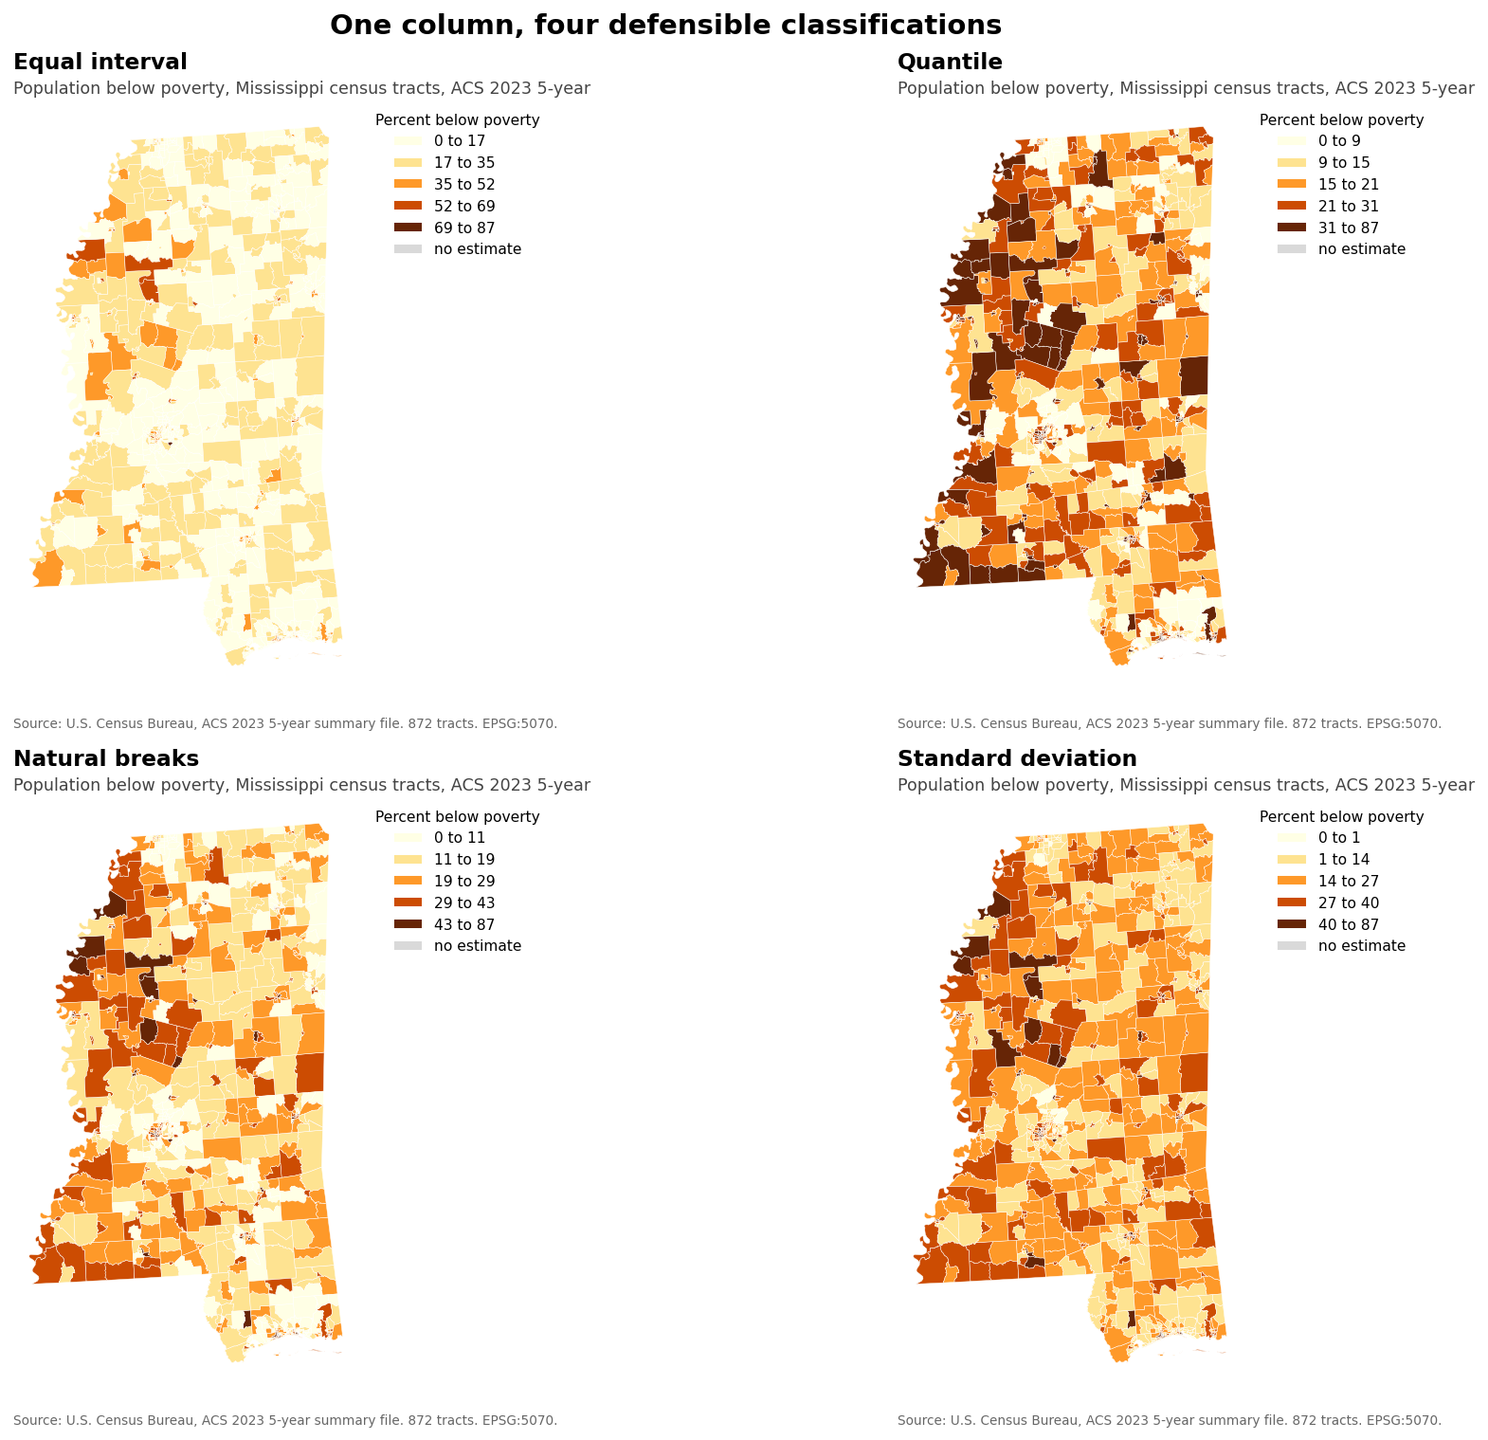
One column, four defensible classifications. 859 of 872 tracts land in a different class under at least one scheme, and exactly one tract sits in the worst class under all four.
II-A.4 Lab II-A Questions
1. Section 4.4 proposes six possible components for an Aggregation Sensitivity Index and this lab implements four of them. Name the two that were omitted, explain what each would require, and state how including them could change the reported index and why the direction cannot be known before computing them.
2. The boundary perturbation test destroys spatial contiguity, because random reassignment scatters each zone across the state. Openshaw's original formulation preserved contiguity. Explain how preserving contiguity would change the distribution you measured, and state which version answers the question a decision maker actually asks.
3. A colleague argues that the block group result should always be preferred because it uses the finest units. Using your Block 5 numbers, explain why that argument fails, and state the conditions under which it would succeed.
4. Your index reported a single number. Section 4.4 warns against interpreting such an index as a universal threshold. Write the two sentences you would place beneath the number in a report to a decision maker who has never heard of the modifiable areal unit problem.
II-A.5 Lab II-A Extra Credit
Optional, up to ten extra credit points.
Section 5.6.4 describes temporal boundary auditing, which compares model output under an old boundary vintage against a new one and identifies locations whose classification changed because the lines moved while conditions on the ground held steady. Census tract boundaries were redrawn between the 2010 and 2020 censuses. Hold the observations fixed by apportioning the 2023 block group counts in the frozen snapshot to 2010 tracts, using the Census Bureau's 2020 to 2010 block relationship file weighted by 2020 block population, then compute the need index on both tract vintages and report how many units changed decile because the lines moved. State what that count means for a program that allocates money by tract decile, and state why an earlier vintage of the survey tables would confound the boundary change with a change in conditions.
II-A.6 Lab II-A Data Package
The data package for this lab consists of 3 files, each already frozen in the snapshots folder of the companion repository and each drawn from the United States Census Bureau, which publishes without registration or a key. The snapshot carries a SHA256 checksum recorded in its manifest, and the program for this lab prints that checksum on every run so a student can confirm the data matches the data the expected values came from. Nothing in the lab touches the network once the snapshot exists, which lets the analysis reproduce offline and years after the original source has changed. The table below lists each file, what it holds and how large it is.
File | Contents | Size
acs2023_mississippi_asi.csv | American Community Survey 2023 five year estimates for Mississippi at county, tract, block group and ZCTA level | 3,832 rows
manifest.json | Row count, vintage and SHA256 checksum of the Census snapshot | 1 record
ms_tracts.geojson | Mississippi census tract boundaries, simplified and projected to EPSG:5070 | 875 polygons; the three water-only tracts in the Census table carry no boundary

Lab II-B. The Analysis That Was Already Wrong
Learning Objectives
Reproduce a delivered analysis before auditing it
Identify an invalid aggregation of medians and quantify its error in dollars
Evaluate whether a technical defect changes the decision it informs, and find the designs where it would
Identify violations of the textbook's strategic recommendations in a delivered product
Write a client-facing review that states consequence before mechanism
Required Software Tools and Setup
Python 3.11 or later with pandas, numpy, scipy and matplotlib
Install command: pip install pandas numpy scipy matplotlib
Regenerating the delivered memorandum also needs python-docx: pip install python-docx
Google Colab, as an alternative for anyone who cannot install Python locally
Any artificial intelligence assistant, for the optional Tier 3 steps
Programs for this lab, all in the toolkit folder of the companion repository:
exercise_2b.py, the audit program
cooling_centers_analysis.py, the delivered analysis under audit
common.py
make_figures.py, draws the audit figure
kriging.py, used by make_figures.py
spatial_stats.py, used by make_figures.py
mapping.py, used by make_figures.py
Lab at a Glance
Textbook sections | sections 4.3, 4.4, 4.5, 5.3, 5.4, 5.6, 6.4
Technical demand | Tier 1 required, Tier 3 optional. Python with pandas and numpy, plus python-docx to regenerate the memorandum and matplotlib and scipy for the audit figure
Effort | two hours including the write up
Prerequisites | none, though students who have completed II-A finish faster

II-B.1 Lab II-B Overview
A consulting firm has delivered a completed analysis recommending which ten Mississippi census tracts should receive a cooling center. The deliverable arrives as a memorandum, a ranked table and the script that produced it, all of which look professional and one of which is wrong. The student's task is to find the defect, quantify what it cost, and write the two paragraph response a client would send back.
This lab inverts II-A. The student receives a finished output and works backward to the diagnostic that would have caught the defect in it. That difference matters for a course where the assistant may already be good enough to avoid the error, because a defect embedded in a delivered file stays defective no matter how capable the assistant becomes.
The supplied analysis contains one defect of substance and two of presentation, and finding all three is the work of the lab.
II-B.2 Lab II-B Step-by-Step Instructions
Step 1: Read the deliverable (Tier 1)
Open cooling_centers_memo.docx, cooling_centers_ranked.csv and cooling_centers_analysis.py from the companion repository. Read the memorandum first, as a client would, and write down the recommendation and the three sentences that justify it before you look at any code.
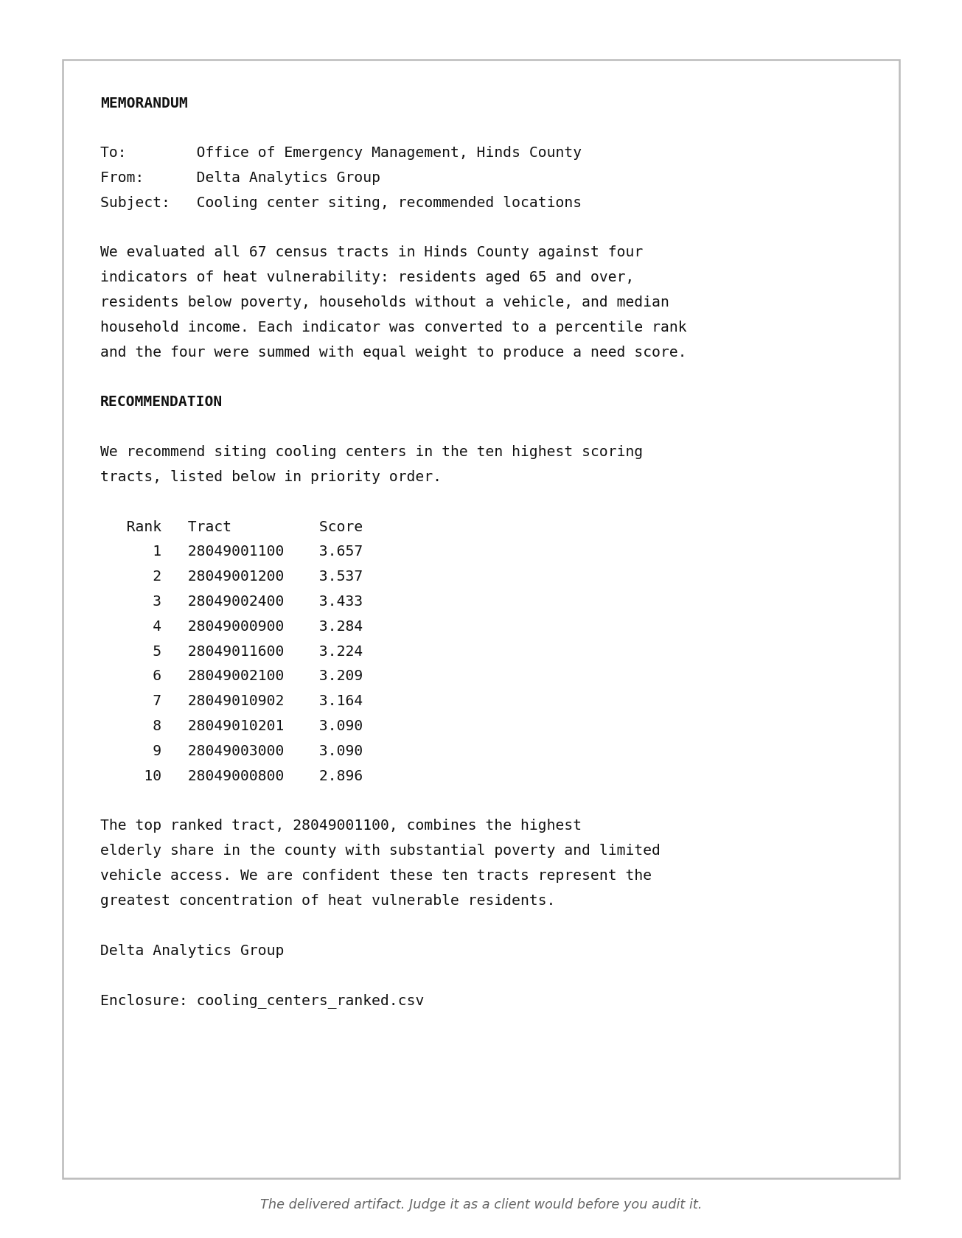
Facsimile. The opening of the delivered consulting memorandum, retypeset for this workbook, so students judge the artifact before they audit it. The delivered file carries a date line and a longer table than the facsimile shows.
Step 2: Reproduce the result (Tier 1)
Copy cooling_centers_ranked.csv to a file named delivered_ranked.csv before you run anything. Then change to the toolkit folder, type python cooling_centers_analysis.py, and confirm that the table it prints matches delivered_ranked.csv. The script rewrites the ranked table and the memorandum each time it runs, and it needs the python-docx library (pip install python-docx) to write the memorandum. An analysis you cannot reproduce cannot be audited, and confirming reproduction is the first step of any review.
Step 3: Find the defect of substance (Tier 1)
The script builds its need index from four variables and one of them is handled incorrectly. Use the frozen snapshot from Lab II-A, which carries both the block group values and the published tract values for every variable, and compare what the script computed at tract level against what the Census Bureau publishes at tract level. The audit program performs that comparison without touching the delivered script: type python exercise_2b.py and read Block 1. Report the mean absolute difference across all tracts, the median absolute difference, the largest single difference, and the percentage of tracts where the difference exceeds five thousand dollars. Then name the statistical property that makes this operation invalid, in one sentence, without using the word average.
Step 4: Quantify the consequence (Tier 1)
Block 2 of the audit program corrects the defect with the published tract medians, reruns the ranking, and reports how many of the ten recommended tracts change. Express the result as a Jaccard overlap and also as a plain count, then identify by GEOID and tract number the tract that gains the most positions and the tract that loses the most.
Figure withheld from this edition. This figure prints values the lab asks you to find, so it appears only in the instructor edition. Your own run of the lab's program produces the numbers it summarizes.
Figure, three panels. The dollar error the invalid aggregation introduces, the overlap of the recommended ten as the weight on income rises, and the overlap as the number of funded places changes. The client does not care about the mean absolute difference. The client cares whether the recommendation changes, and the difference between those two framings is the difference between a technical finding and a consequential one.
Step 5: Find where it matters (Tier 1)
Block 3 reruns the delivered and corrected rankings with the income input weighted two, three, five and eight times, and again with the county funding five, ten, fifteen and twenty places, reporting the overlap each time. State the smallest change to the consultant's design at which the defect alters the recommendation, and explain how an invalid method could leave one design untouched while changing its neighbors.
Step 6: Find the two presentation defects (Tier 1)
Section 4.5 makes eight strategic recommendations and the delivered analysis violates several of them. Name the two that the memorandum's missing statements violate most directly, cite each recommendation number, and state in one sentence each what the memorandum would have to add to comply.
Step 7: Write the response (Tier 1)
Write the two paragraph reply a client would send to the consulting firm. The first paragraph states what is wrong and what it cost, in the client's language and with the numbers from Steps 4 and 5. The second states what the firm must deliver to close the finding. Do not exceed two paragraphs, because a review that runs longer than the deliverable it reviews does not get read.
Step 8: Ask the assistant to audit it (Tier 3, optional, ten points)
Give any assistant the script and the single instruction Review this analysis and tell me whether the recommendation is sound. Record whether it found the defect of substance, whether it found either presentation defect, and whether it raised anything the lab did not anticipate. Then give it the same script with the instruction This analysis aggregates a median. Explain why that is invalid and quantify the error using the tract values in the attached snapshot. Report both outcomes. Say so plainly if the assistant found the defect unprompted, and record which assistant and which version, because that observation is data your instructor can use.
II-B.3 Lab II-B Key Takeaways: The Analysis That Was Already Wrong
Medians do not aggregate, and no amount of careful coding around that fact repairs it. The Census Bureau publishes a tract median because computing one requires the underlying distribution, which the block group median does not carry. A script that averages medians runs cleanly, produces plausible numbers, and stays wrong in a way no error message will ever report.
A defect matters in proportion to what it changes. The mean error in dollars is the technical finding and the change in the recommended list is the consequential one, and a reviewer who reports only the former has not finished the review. Section 5.4 traces how a cartographic mismatch becomes an institutional outcome once a model output drives a funding priority, and section 5.4.1 asks whether funding priorities remain stable under alternative spatial representations. A reviewer tests the neighboring designs before declaring any defect harmless, because an invalid step can leave one design untouched while it changes its neighbors.
Reviewing an artifact is a different skill from producing one and the two do not automatically transfer. Most graduates will spend more of their careers evaluating analyses somebody else produced than producing their own, and this lab practices that skill most directly, with Lab VI-B returning to it when students mark up an assistant's unaided risk register. The review also has to land in language the client understands, which is why Step 7 caps the response at two paragraphs and asks for the consequence before the mechanism. A finding nobody acts on has the same effect on the decision as a finding nobody made.
II-B.4 Lab II-B Data Package
The data package for this lab consists of 3 files, each already frozen in the snapshots folder of the companion repository and each drawn from the United States Census Bureau, which publishes without registration or a key. The snapshot carries a SHA256 checksum recorded in its manifest, and the program for this lab prints that checksum on every run so a student can confirm the data matches the data the expected values came from. Nothing in the lab touches the network once the snapshot exists, which lets the analysis reproduce offline and years after the original source has changed. The table below lists each file, what it holds and how large it is.
File | Contents | Size
acs2023_mississippi_asi.csv | American Community Survey 2023 five year estimates for Mississippi at county, tract, block group and ZCTA level | 3,832 rows
cooling_centers_memo.docx | The delivered consulting memorandum | 1 document
cooling_centers_ranked.csv | The delivered ranked table | 67 tracts

Part III. Behavioral and Institutional Risk: Fragility
Chapters 7, 8 and 9 turn from the geography a model represents to the people and institutions acting upon its outputs. Chapter 7 develops strategic spatial adaptation and specifies a Spatial Exploitability Assessment in section 7.10 and Spatial Red Teaming in 7.11. Chapter 8 develops institutional overreliance and specifies an Institutional Overreliance Assessment in 8.10 and Dependency Stress Testing in 8.11. Chapter 9 develops spatial information asymmetry and specifies a Spatial Information Asymmetry Assessment in 9.10 and Blind-Spot Mapping and Information-Parity Testing in 9.11. Neither exercise in this Part reaches Chapter 8, and Labs 0-A and VI-B carry its section 8.14 on meaningful human authority.
Fundamentals in play. These labs use composite index construction, percentile ranking, sensitivity of a rank to its inputs, sampling error as published by a survey program, and the coefficient of variation as a reliability screen. Three of them fail in characteristic ways. A composite index inherits every weakness of its weakest input, a percentile is relative so improving one unit moves others, and a coefficient of variation computed from a published margin of error assumes that margin was computed for the estimate you are using and never for a derived quantity.

Lab III-A. The Spatial Exploitability Assessment
Learning Objectives
Recompute a composite need index from its documented inputs
Identify the input carrying the most leverage over a percentile ranking
Predict and then measure how universal gaming reorders a relative score
Evaluate a mitigation by what it costs in fairness or responsiveness
Rate an index against the five conditions of the Spatial Exploitability Assessment
Required Software Tools and Setup
Python 3.11 or later with pandas, numpy, scipy and matplotlib
Install command: pip install pandas numpy scipy matplotlib
Google Colab, as an alternative for anyone who cannot install Python locally
Any artificial intelligence assistant, for the optional Tier 3 steps
Programs for this lab, all in the toolkit folder of the companion repository:
exercise_3a.py
common.py
mapping.py
Lab at a Glance
Textbook sections | sections 7.3, 7.4, 7.9, 7.10, 7.11, 7.12
Technical demand | Tier 1 and Tier 2 required, Tier 3 optional. Python with pandas, numpy and matplotlib
Effort | three to four hours including the write up
Prerequisites | Lab II-A

III-A.1 Lab III-A Overview
Section 7.4 defines the spatial gaming surface as any predictable spatial, temporal, classificatory, observational or institutional feature of a decision system that an informed actor can exploit to alter how the system observes, classifies, predicts or responds. The top decile cut in this lab is a threshold, the third of the six common gaming surfaces in section 7.4.1. This lab builds a need index from documented Census inputs, treats it as a system under audit, and asks what the cheapest change is that moves a tract out of the highest scoring decile. The answer identifies which input carries disproportionate leverage in the arithmetic of the index. Whether an actor would concentrate there depends on the Adaptability condition in section 7.10.4, because the cheapest input may be one no actor can change, and on the Advantage condition, because under a funding formula the incentive runs toward entering the decile, the opposite of the direction the program searches.
Section 7.10 specifies the Spatial Exploitability Assessment as a chain of five conditions, and section 7.11 lists controlled perturbations among the ways a red team simulates adaptation. The lab runs a controlled perturbation against an index the student built and can therefore inspect completely, and it uses the result as evidence for the Opportunity and Adaptability conditions.
The lab then applies that perturbation to every tract in the top decile simultaneously and recomputes. Because a percentile is relative, tracts that took no action move into the decile while tracts that acted move out, and the resulting reordering is not what any individual actor anticipated. Section 7.9 argues that informed actors learn the institution's response through repeated interaction and that static validation fails once the relationship being modeled changes in response to the model. The lab extends that argument to a relative score, where collective adaptation moves tracts that took no action, and produces the result as a table and a map. Students should record their prediction of the outcome before reading block 3 of the printed report, because the result contradicts the intuition most of them bring to it.
III-A.2 Lab III-A Step-by-Step Instructions
Step 1: Build and verify the index (Tier 1)
Change to the toolkit folder inside GeoAI_Exercises, type python exercise_3a.py, and record the index construction, the number of tracts in the top decile, and the threshold value. Confirm that the checksum the program prints matches the first 32 characters of the sha256 value in manifest.json, because an audit that cannot show it holds the same data as the thing it audits has established nothing.
Step 2: Find the leverage (Tier 1)
The program computes, for each top decile tract, the minimum change in each single input that would drop it below the threshold. Record the input the program reports as the cheapest lever, meaning the input with the smallest median cut, and record that median. Then state which direction of change a jurisdiction facing a funding formula built on this index would pursue under the Advantage condition of section 7.10, and whether the program's search runs in that direction.
Figure withheld from this edition. This figure prints values the lab asks you to find, so it appears only in the instructor edition. Your own run of the lab's program produces the numbers it summarizes.
Figure. Leverage by input variable, as a bar chart of the median cut each input requires to move a tract out of the top decile.
Step 3: Apply it universally (Tier 1)
The program cuts the cheapest input in every top decile tract by the median minimum cut from Step 2 and recomputes all percentiles. Record how many tracts left the decile, how many entered, and the Jaccard overlap between the original and revised sets. Explain why any tract entered without changing.
Step 4: Map the churn (Tier 1)
The program maps three categories, being tracts that stayed, tracts that left and tracts that entered. Describe the geographic pattern of the entering tracts and state whether they share anything the index does not measure.
Figure withheld from this edition. This figure prints values the lab asks you to find, so it appears only in the instructor edition. Your own run of the lab's program produces the numbers it summarizes.
Map, three categories. Tracts that stayed in the top decile, tracts that left, and tracts that entered without acting.
Step 5: Red team it (Tier 2)
Section 7.11 organizes spatial red teaming in five stages, from defining the decision effect through modeling what a realistic actor could observe, infer, afford and change, simulating adaptation with controlled perturbations, and measuring mission consequence. The perturbation budget stands for what the actor can afford and change. Block 4 sweeps the budgets listed in BUDGETS at the top of exercise_3a.py. Record the Jaccard overlap at each, then add a budget of your own to BUDGETS, rerun, and record the result. Identify the budget at which the top decile becomes substantially unrecognizable and state what that budget corresponds to in the real world.
Step 6: Mitigate (Tier 2)
Section 7.12 proposes exploitation resilient design, and section 7.12.1 recommends continuous risk surfaces, uncertainty bands, multiple evidence sources or graduated decision rules so that a consequential decision does not hinge on one brittle line. Block 5 of the program runs one mitigation, a threshold fixed in advance of the gaming, and reports how many tracts left and entered and the new overlap. Record those values and state what the fixed threshold cost in fairness or responsiveness, because each mitigation costs something. Students who take the optional Tier 3 extension have an assistant implement one of the section 7.12.1 designs, such as an ensemble of indices or a graduated decision rule, then rerun the universal perturbation and compare.
Step 7: Apply the assessment (Tier 1)
Section 7.10 organizes the Spatial Exploitability Assessment around five conditions, being Exposure, Predictability, Opportunity, Adaptability and Advantage. Rate this index on each condition as present, partial or absent, and cite for each rating a number from Steps 1 through 6 or state that no step measured it.
Step 8: Read the code and complete the handoff (Tier 1)
Annotate the leverage search block and answer the decisions file.
Step 9: Ask the assistant (Tier 3, optional, ten points)
Ask an assistant how a county could improve its standing under this index, record what it produced, and state whether it raised the ethics of the request unprompted.
III-A.3 Lab III-A Data Package
The data package for this lab consists of 3 files, each already frozen in the snapshots folder of the companion repository and each drawn from the United States Census Bureau, which publishes without registration or a key. The snapshot carries a SHA256 checksum recorded in its manifest, and the program for this lab prints that checksum on every run so a student can confirm the data matches the data the expected values came from. Nothing in the lab touches the network once the snapshot exists, which lets the analysis reproduce offline and years after the original source has changed. The table below lists each file, what it holds and how large it is.
File | Contents | Size
acs2023_mississippi_asi.csv | American Community Survey 2023 five year estimates for Mississippi at county, tract, block group and ZCTA level | 3,832 rows
manifest.json | Row count, vintage and SHA256 checksum of the Census snapshot | 1 record
ms_tracts.geojson | Mississippi census tract boundaries, simplified and projected to EPSG:5070 | 875 polygons; the three water-only tracts in the Census table carry no boundary

Lab III-B. Blind-Spot Mapping and the Reliability Screen
Learning Objectives
Compute coefficients of variation from published margins of error at three geographies
Produce estimate, reliability and screened maps from a single download
Determine how many of the poorest units rest on unreliable evidence
Test whether small and large communities are represented by evidence of equal quality
Rate a map against the five dimensions of the Spatial Information Asymmetry Assessment
Required Software Tools and Setup
Python 3.11 or later with pandas, numpy, scipy and matplotlib
Install command: pip install pandas numpy scipy matplotlib
Google Colab, as an alternative for anyone who cannot install Python locally
Any artificial intelligence assistant, for the optional Tier 3 steps
Programs for this lab, all in the toolkit folder of the companion repository:
exercise_3b.py
common.py
make_figures.py, draws the three maps
kriging.py, used by make_figures.py
spatial_stats.py, used by make_figures.py
mapping.py, used by make_figures.py
Lab at a Glance
Textbook sections | sections 9.2, 9.3, 9.4, 9.10, 9.11, 9.12, and section 4.5 recommendation 3
Technical demand | Tier 1 and Tier 2 required. Python with pandas, numpy, scipy and matplotlib
Effort | two to three hours including the write up
Prerequisites | none

III-B.1 Lab III-B Overview
Section 9.3 identifies three forms of spatial information asymmetry, and section 9.4 develops the blind-spot problem, defining a blind spot by whether its absence from the information system can change a consequential decision and separating visible missingness from silent missingness. The American Community Survey supplies the cleanest available case, because the Census Bureau publishes a margin of error beside every estimate and almost nobody maps it. A block group choropleth of median household income presents an impression of uniform local precision that the sampling behind it does not support anywhere near uniformly.
Students compute the coefficient of variation for every unit at three geographies, count how many exceed a thirty percent coefficient of variation, a reliability cutoff commonly applied to American Community Survey estimates, count how many estimates were suppressed outright, and produce three maps from one download. The third map suppresses every unit failing the screen, and the difference between the first and third maps marks the silent missingness of section 9.4, units the first map colors with the same confidence as the rest although their evidence fails the screen. Section 9.12 prescribes what an asymmetry-resilient system shows, including visible missingness in section 9.12.1 and the pairing of an estimate with the quality of its evidence in section 9.12.2. The lab ends by requiring the student to decide what to release, one of the three maps or a combination of them, and to defend the decision against those two subsections.
III-B.2 Lab III-B Step-by-Step Instructions
Step 1: Run the screen (Tier 1)
Change to the toolkit folder inside GeoAI_Exercises, type python exercise_3b.py, and record, for block group, tract and county, the number of estimates present, the number suppressed, the percentage exceeding a thirty percent coefficient of variation, and the median coefficient of variation. Describe the direction of the pattern across the three geographies in one sentence.
Step 2: Map the three products (Tier 1)
Record the estimate map, the reliability map and the screened map. The three maps are drawn at tract level, the finest geography for which the package ships boundaries, so they show a smaller share of failing units than the block group screen in Step 1 reports. Then write the caption you would place under the first map so that a reader understands what it does and does not support, in no more than two sentences.
Figure withheld from this edition. This figure prints values the lab asks you to find, so it appears only in the instructor edition. Your own run of the lab's program produces the numbers it summarizes.
Map, three panels at tract level. The estimate, the coefficient of variation, and the estimate with unreliable units suppressed, on a shared extent.
Step 3: Find what the ranking rested on (Tier 1)
Record how many of the ten lowest income block groups fail the reliability screen. State what that means for a program that allocates resources to the ten most distressed block groups in the state.
Step 4: Locate the loss (Tier 1)
The margin of error arrives in the column adjacent to the estimate in the same download. Trace the point in a normal workflow at which that column stops traveling with the estimate, and name the role in an organization who would have had to notice.
Step 5: Test information parity (Tier 2)
Section 9.11 describes information-parity testing, which stratifies validation by variables that influence visibility and asks whether performance degrades as information thins. Apply the evidence half of that test. Block 3 compares the reliability of estimates in the smallest and largest population quintiles of tracts. Report the difference and state which communities are systematically represented by weaker evidence. Then change CV_LIMIT at the top of exercise_3b.py to 20 and then to 40, rerunning after each change, and report how the gap between the smallest and largest quintiles moves.
Step 6: Apply the assessment (Tier 1)
Section 9.10 organizes the Spatial Information Asymmetry Assessment around five dimensions, being Coverage, Currency, Access, Representation and Contestability. Rate the block group income map on each dimension, and cite for each rating a number from Steps 1 through 5 or state that no step measured it.
Step 7: Read the code and complete the handoff (Tier 1)
Annotate the coefficient of variation computation, including the division by 1.645, and answer the decisions file.
III-B.3 Lab III-B Data Package
The data package for this lab consists of 3 files, each already frozen in the snapshots folder of the companion repository and each drawn from the United States Census Bureau, which publishes without registration or a key. The snapshot carries a SHA256 checksum recorded in its manifest, and the program for this lab prints that checksum on every run so a student can confirm the data matches the data the expected values came from. Nothing in the lab touches the network once the snapshot exists, which lets the analysis reproduce offline and years after the original source has changed. The table below lists each file, what it holds and how large it is.
File | Contents | Size
acs2023_mississippi_asi.csv | American Community Survey 2023 five year estimates for Mississippi at county, tract, block group and ZCTA level | 3,832 rows
manifest.json | Row count, vintage and SHA256 checksum of the Census snapshot | 1 record
ms_tracts.geojson | Mississippi census tract boundaries, simplified and projected to EPSG:5070 | 875 polygons; the three water-only tracts in the Census table carry no boundary

Part IV. Systemic Risk and Uncertainty: Feedback Loops
Chapters 10, 11 and 12 trace a progression from propagation to absence to recursion: uncertainty that moves through a decision system, risk that never enters it, and decisions that change the evidence the system later learns from. Chapter 10 specifies an Uncertainty Cascade Assessment in section 10.10 and sensitivity, ensemble and traceback testing in 10.11. Chapter 11 specifies an Unmapped Risk Assessment in 11.10 and testing the unknown in 11.11. Chapter 12 specifies the GeoAI Feedback Reflex Assessment in 12.10 and intervention aware validation in 12.11.
Fundamentals in play. These labs use Monte Carlo propagation of published margins of error, random seeds and reproducibility, rank stability under simulated sampling error, and iterated simulation. Each fails in a known way. A Monte Carlo result is only as good as the distribution assumed for each input, an unstated seed makes a result irreproducible while looking rigorous, rank stability measured under one error model says nothing about the errors that model leaves out, and an iterated simulation whose sampling depends on its current estimate chases whatever its early observations happened to favor, concentrating effort far above the correct level without settling.

Lab IV-A. The Uncertainty Cascade Assessment
Learning Objectives
Propagate published margins of error through an index, a threshold and a population count
Report a point estimate alongside the interval the survey supports
Measure how often a top ranked unit holds its rank under sampling error
Demonstrate seed discipline and explain why an unseeded analysis cannot be reproduced
Build an ensemble across weightings and identify the units every configuration selects
Required Software Tools and Setup
Python 3.11 or later with pandas, numpy, scipy and matplotlib
Install command: pip install pandas numpy scipy matplotlib
Google Colab, as an alternative for anyone who cannot install Python locally
Any artificial intelligence assistant, for the optional Tier 3 steps
Programs for this lab, all in the toolkit folder of the companion repository:
exercise_4a.py
common.py
mapping.py
Lab at a Glance
Textbook sections | sections 10.2, 10.3, 10.4, 10.5, 10.10, 10.11, 10.12, 10.13, 15.7.2
Technical demand | Tier 1 and Tier 2 required. Python with pandas, numpy and matplotlib
Effort | three hours including the write up
Prerequisites | Labs II-A and III-B

IV-A.1 Lab IV-A Overview
Section 10.3 describes the anatomy of an uncertainty cascade, in which uncertainty entering at one of six linked stages passes downstream, where later stages inherit, transform, amplify or mask it. Section 10.4 names spatial overconfidence, in which precision outruns evidence. This lab runs a cascade end to end on published margins of error and reports what arrives at the far end.
The chain has three links. Published estimates carrying published margins of error feed a composite index, the index feeds a threshold that selects qualifying tracts, and the selection feeds a population count of the kind that appears in a funding request. Students draw a thousand realizations, sampling each of the three numerators from its own published error distribution while holding the denominators and the tract populations at their published estimates, and report the fifth to ninety fifth percentile range of that final count alongside the single number the point estimate produced. The single number masks the interval, which section 10.3.4 calls masking, and the tract by tract selection examined in Step 3 claims a geographic precision that section 10.4 calls spatial overconfidence.
Section 10.10 organizes the Uncertainty Cascade Assessment around six dimensions, being Source, Transformation, Dependency, Sensitivity, Visibility and Consequence. The steps below exercise five of them. The sampling block identifies the Source, the index and the threshold carry the Transformation, Steps 2 and 3 measure Sensitivity, the comparison between the point estimate and the interval measures Visibility, and the funding count in Step 6 carries the Consequence. The program draws each numerator independently, which is the treatment the Dependency dimension exists to question, and the handoff asks what correlated errors would do to the interval.
IV-A.2 Lab IV-A Step-by-Step Instructions
Step 1: Establish the point estimate (Tier 1)
Change to the toolkit folder inside GeoAI_Exercises and type python exercise_4a.py. Record the qualifying tract count and the population inside them under the published estimates with no simulation. This is the number that would appear in a report.
Step 2: Run the cascade (Tier 1)
Record the fifth, fiftieth and ninety fifth percentiles of the population count across a thousand realizations with the stated seed. State the width of that interval as a percentage of the point estimate.
Figure withheld from this edition. This figure prints values the lab asks you to find, so it appears only in the instructor edition. Your own run of the lab's program produces the numbers it summarizes.
Figure. Histogram of the final population count across a thousand realizations, with the point estimate marked and the fifth to ninety fifth percentile band shaded.
Step 3: Test rank retention (Tier 1)
Record the probability that the tract ranked first under the point estimate ranks first in a realization, and record how many distinct tracts appear in the selected set at least once. Section 10.4 defines spatial overconfidence as apparent geographic precision that exceeds the precision, coverage or stability of the supporting evidence, and these two numbers measure the stability of the tract selection.
Step 4: Demonstrate reproducibility (Tier 1)
Block 3 reruns one realization twice with the stated seed and once with seed 1. Confirm the first two match exactly, record the change the third produces, and state why an analysis that omits its seed is irreproducible even when its code is published.
Step 5: Build the ensemble (Tier 2)
Section 10.11 asks for ensembles. Block 4 recomputes the qualifying set from the point estimates under the three index weightings listed in WEIGHTINGS at the top of exercise_4a.py and reports the union and intersection of those three sets. Record both, then add a fourth weighting of your own choosing to WEIGHTINGS, rerun, and report how the union and intersection change. State which tracts qualify under every configuration. Section 10.11 treats agreement across an ensemble as a sign of a stable conclusion, and section 10.5 warns that configurations built on the same inputs supply much less independent evidence, so these tracts have survived the weighting choice and nothing more.
Step 6: Communicate it (Tier 1)
Section 10.12 warns against communicating uncertainty in ways that paralyze decisions. Write the two sentences you would put beneath the number in a funding request, conveying the interval without inviting the reader to discard the analysis.
Step 7: Read the code and complete the handoff (Tier 1)
Annotate the sampling block, including the division that converts a margin of error to a standard deviation, and answer the decisions file.
IV-A.3 Lab IV-A Data Package
The data package for this lab consists of 3 files, each already frozen in the snapshots folder of the companion repository and each drawn from the United States Census Bureau, which publishes without registration or a key. The snapshot carries a SHA256 checksum recorded in its manifest, and the program for this lab prints that checksum on every run so a student can confirm the data matches the data the expected values came from. Nothing in the lab touches the network once the snapshot exists, which lets the analysis reproduce offline and years after the original source has changed. The table below lists each file, what it holds and how large it is.
File | Contents | Size
acs2023_mississippi_asi.csv | American Community Survey 2023 five year estimates for Mississippi at county, tract, block group and ZCTA level | 3,832 rows
acs2023_mississippi_moe.csv | Margins of error for the count tables behind the need index | 3,405 rows
ms_tracts.geojson | Mississippi census tract boundaries, simplified and projected to EPSG:5070 | 875 polygons; the three water-only tracts in the Census table carry no boundary

Lab IV-B. The GeoAI Feedback Reflex Assessment
Learning Objectives
Simulate a predictive allocation loop on real geography with a known uniform truth
Explain feedback laundering and why agreement measured on self generated observations cannot establish predictive validity
Determine the exploration fraction that holds allocation within a stated tolerance, and defend the tolerance
Design intervention aware validation for a biased observation log
Required Software Tools and Setup
Python 3.11 or later with pandas, numpy, scipy and matplotlib
Install command: pip install pandas numpy scipy matplotlib
Google Colab, as an alternative for anyone who cannot install Python locally
Any artificial intelligence assistant, for the optional Tier 3 steps
Programs for this lab, all in the toolkit folder of the companion repository:
exercise_4b.py
common.py
mapping.py
Lab at a Glance
Textbook sections | sections 12.2, 12.3, 12.4, 12.5, 12.10, 12.11, 12.12
Technical demand | Tier 1 and Tier 2 required, Tier 3 optional. Python with numpy, pandas and matplotlib
Effort | three hours including the write up
Prerequisites | none

IV-B.1 Lab IV-B Overview
Section 12.3 describes the anatomy of a self-fulfilling spatial error and section 12.4 names feedback laundering, in which intervention gets mistaken for validation. This lab builds the loop on Mississippi tract geography with an event rate set identical in every tract, so any concentration the model produces is an artifact and nothing else.
Each iteration allocates a fixed inspection budget in proportion to the current risk score, observes events only where it inspected, and refits the score on observations accumulated so far. The effort concentrates within the first few iterations in whichever tracts happened to record early events, and it decays only partway by iteration 20. Students then add a reserved fraction of random allocation, sweep that fraction, and report the smallest value that holds the top decile share of effort within the tolerance the program states. That fraction is a design parameter with a defensible value, which converts a general warning about feedback into something an engineer can specify.
Section 12.10 organizes the GeoAI Feedback Reflex Assessment around five dimensions, being Intervention, Observation, Independence, Adaptation and Persistence. The simulation exercises the first three, because the budget is the intervention, events are observed only where effort goes, and the refit consumes observations that are no longer independent of the model. Adaptation and Persistence fall outside it, since nothing in the simulated tracts responds to inspection and the loop runs for twenty iterations only.
IV-B.2 Lab IV-B Step-by-Step Instructions
Step 1: Run the uncorrected loop (Tier 1)
Change to the toolkit folder inside GeoAI_Exercises and type python exercise_4b.py. Record the share of the inspection budget falling in the top decile of tracts at iterations 1, 5, 10 and 20. The true rate is uniform, so any lasting concentration comes from the loop itself.
Step 2: Map the outcome (Tier 1)
Record the map of cumulative inspection effort at iteration 20 and describe the pattern, then state what a reviewer shown only that map, with no knowledge of the simulation, would conclude about the geography of the phenomenon.
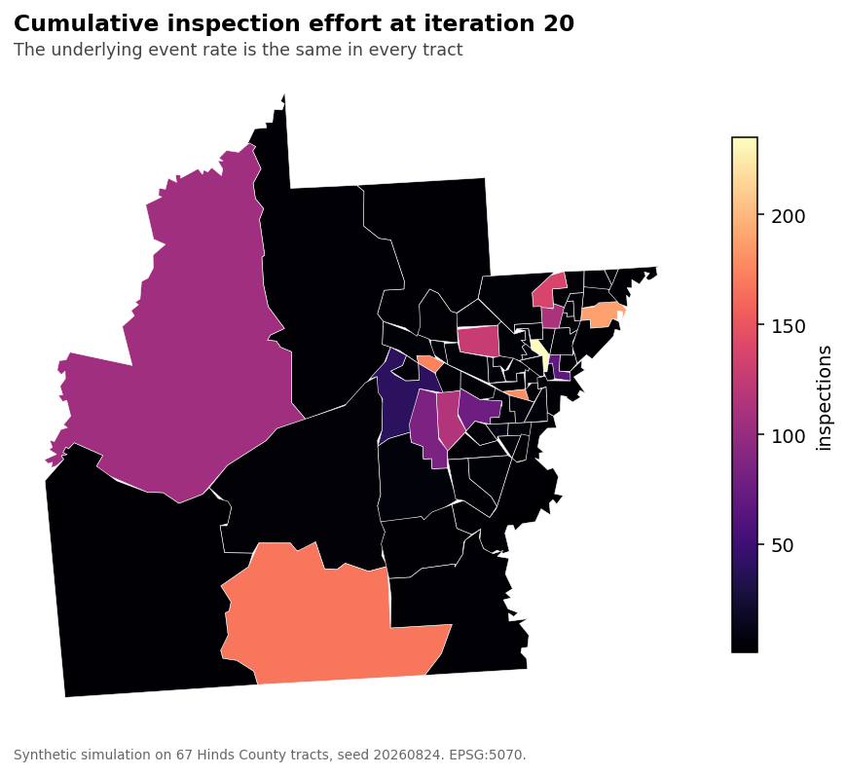
Map. Cumulative inspection effort at iteration twenty under the uncorrected loop, with a subtitle stating that the true rate is identical everywhere.
Step 3: Demonstrate the laundering (Tier 1)
The program reports the correlation between each tract's cumulative inspection effort and its observed event rate, the indicator Table 12.10.5.1 lists as risk scores correlating with inspection intensity. Record it, note that it is high, and explain in one paragraph why agreement with observations the model chose to collect cannot separate genuine predictive validity from self confirmation. The true rate here is identical everywhere, so in this simulation the agreement reflects self confirmation alone. Section 12.5 explains why conventional validation can miss the loop.
Step 4: Add exploration (Tier 2)
Record the top decile share at iteration 20 under the reserved random fractions listed in EXPLORE at the top of exercise_4b.py, being none, ten, twenty and thirty percent. Identify the smallest fraction holding the share below the program's tolerance of 20 percent, set in TOLERANCE, then add a fraction of your own to EXPLORE, rerun, and refine the estimate. State whether you would defend that tolerance, and why.
Figure withheld from this edition. This figure prints values the lab asks you to find, so it appears only in the instructor edition. Your own run of the lab's program produces the numbers it summarizes.
Figure. Top decile share of effort against iteration, one line per exploration fraction, with the ten percent correct level drawn as a reference.
Step 5: Validate the intervention aware way (Tier 3, optional)
Section 12.11 asks for validation that accounts for the intervention. Block 4 pools every inspection into one rate and computes no held out statistic, so this step asks for an extension. Have an assistant modify the loop so the random share of each iteration's budget is logged separately and serves as the only validation set, report the agreement between the model's score and the rate observed in that random sample, and compare it with the self generated agreement from Step 3.
Step 6: Read the code and complete the handoff (Tier 1)
Annotate the score update line, which is where the loop closes, and answer the decisions file.
IV-B.3 Lab IV-B Data Package
The data package for this lab consists of 2 files, each already frozen in the snapshots folder of the companion repository and each drawn from the United States Census Bureau, which publishes without registration or a key. The snapshot carries a SHA256 checksum recorded in its manifest, and the program for this lab prints that checksum on every run so a student can confirm the data matches the data the expected values came from. Nothing in the lab touches the network once the snapshot exists, which lets the analysis reproduce offline and years after the original source has changed. The table below lists each file, what it holds and how large it is.
File | Contents | Size
acs2023_mississippi_asi.csv | American Community Survey 2023 five year estimates for Mississippi at county, tract, block group and ZCTA level | 3,832 rows
ms_tracts.geojson | Mississippi census tract boundaries, simplified and projected to EPSG:5070 | 875 polygons; the three water-only tracts in the Census table carry no boundary

Part V. Adversarial and Emerging Risks
Chapters 13 and 14 concern signals that mislead by construction or by intent. Chapter 13 specifies a Proxy Integrity Assessment in section 13.10 and testing beyond statistical fit in 13.11, and develops adversarial proxy manipulation in 13.13. Chapter 14 specifies an Adversarial GeoAI Exposure Assessment in section 14.9 and Adversarial Stress Testing in 14.10.
Fundamentals in play. These labs use surrogate variables, correlation as evidence of substitutability, rank agreement between a proxy and its referent, and sensitivity of a ranking to injected records. The failure modes are that a proxy correlated with its referent in aggregate can diverge exactly where the decision is made, and that a ranking built from counts can be moved by a small number of fabricated records.

Lab V-A. The Proxy Integrity Assessment
Learning Objectives
Measure the global agreement between a proxy and its referent
Compare that agreement with the overlap among the units a program would select
Identify what each stand-in rewards by comparing the divergent groups
Test whether the divergence survives a reliability screen
Rate a proxy against the six dimensions of the Proxy Integrity Assessment
Required Software Tools and Setup
Python 3.11 or later with pandas, numpy, scipy and matplotlib
Install command: pip install pandas numpy scipy matplotlib
Google Colab, as an alternative for anyone who cannot install Python locally
Any artificial intelligence assistant, for the optional Tier 3 steps
Programs for this lab, all in the toolkit folder of the companion repository:
exercise_5a.py
common.py
mapping.py
Lab at a Glance
Textbook sections | sections 13.2, 13.3, 13.4, 13.10, 13.11, 13.12
Technical demand | Tier 1 and Tier 2 required. Python with pandas, numpy and matplotlib
Effort | two to three hours including the write up
Prerequisites | Labs II-A and III-B

V-A.1 Lab V-A Overview
Section 13.2 develops proxy logic, in which an observable or derivable measure represents a condition that is difficult or impossible to observe directly at the required scale, frequency or cost. Median household income routinely stands in for need, and it correlates with need well enough that the substitution passes casual inspection. This lab measures where the substitution holds and where it fails.
Students compare a ranking of Mississippi tracts by median income against a ranking by the three variable need index, report the correlation between them, and then report the agreement among the top ranked units specifically. Section 13.11 argues for testing beyond statistical fit, and this lab asks whether a strong global correlation guarantees agreement among exactly the units a program would fund. The program calls the three variable index the referent, and the index is itself a composite surrogate in the sense of Table 13.2.1, so the lab measures how far two stand-ins for need disagree and cannot settle which one sits closer to need.
V-A.2 Lab V-A Step-by-Step Instructions
Step 1: Establish the correlation (Tier 1)
Change to the toolkit folder inside GeoAI_Exercises and type python exercise_5a.py. Record the correlation between the income proxy and the composite referent across all tracts, and state whether it appears strong enough to justify the substitution.
Step 2: Test where the decision happens (Tier 1)
Record the Jaccard overlap between the fifty lowest income tracts and the fifty highest need tracts. Compare that overlap against the correlation from Step 1 and state which of the two a program manager should care about.
Step 3: Name the divergent units (Tier 1)
Block 3 of the program prints the mean age, poverty, vehicle access and income of the tracts chosen by one ranking and not the other, and the review table exercise_5a_for_review.csv flags every tract's selection. Filter that table for ten tracts the index selects and income does not, and identify which index inputs set them apart.
Step 4: Map the disagreement (Tier 1)
Record the map showing tracts selected by the proxy alone, by the referent alone, and by both. Describe the geographic pattern of each category.
Figure withheld from this edition. This figure prints values the lab asks you to find, so it appears only in the instructor edition. Your own run of the lab's program produces the numbers it summarizes.
Map, three categories. Tracts selected by the income proxy alone, by the composite referent alone, and by both.
Step 5: Screen for reliability (Tier 2)
Section 13.11 allows a proxy that fails a test to continue under stronger measurement or a restricted operating domain. Block 4 restricts the comparison to tracts passing the reliability screen from Lab III-B and reports whether agreement improves. Record the result, then change CV_LIMIT at the top of exercise_5a.py from 30 to 20 and to 40, rerunning after each change, and report how the overlap and the surviving tract count move. State what that says about whether the divergence is substantive or an artifact of measurement error.
Step 6: Apply the assessment (Tier 1)
Section 13.10 organizes the Proxy Integrity Assessment around six dimensions, being Meaning, Mechanism, Transfer, Independence, Stability and Consequence. Rate the income proxy on each dimension, and cite for each rating a number from Steps 1 through 5 or state that no step measured it.
Step 7: Read the code and complete the handoff (Tier 1)
Annotate the ranking comparison block and answer the decisions file.
V-A.3 Lab V-A Data Package
The data package for this lab consists of 2 files, each already frozen in the snapshots folder of the companion repository and each drawn from the United States Census Bureau, which publishes without registration or a key. The snapshot carries a SHA256 checksum recorded in its manifest, and the program for this lab prints that checksum on every run so a student can confirm the data matches the data the expected values came from. Nothing in the lab touches the network once the snapshot exists, which lets the analysis reproduce offline and years after the original source has changed. The table below lists each file, what it holds and how large it is.
File | Contents | Size
acs2023_mississippi_asi.csv | American Community Survey 2023 five year estimates for Mississippi at county, tract, block group and ZCTA level | 3,832 rows
ms_tracts.geojson | Mississippi census tract boundaries, simplified and projected to EPSG:5070 | 875 polygons; the three water-only tracts in the Census table carry no boundary

Lab V-B. Adversarial Stress Testing
Learning Objectives
State an explicit threat model for a published ranking
Determine the smallest injection of fabricated records that moves a chosen unit
Measure the side effects of an attack on other units
Evaluate a detection control by what it catches and what its false positives cost
Required Software Tools and Setup
Python 3.11 or later with pandas, numpy, scipy and matplotlib
Install command: pip install pandas numpy scipy matplotlib
Google Colab, as an alternative for anyone who cannot install Python locally
Any artificial intelligence assistant, for the optional Tier 3 steps
Programs for this lab, all in the toolkit folder of the companion repository:
exercise_5b.py
common.py
mapping.py
Lab at a Glance
Textbook sections | sections 14.2, 14.3, 14.8, 14.9, 14.10, 14.11
Technical demand | Tier 1 and Tier 2 required. Python with pandas, numpy and matplotlib
Effort | three hours including the write up
Prerequisites | Labs II-A and III-A

V-B.1 Lab V-B Overview
Every action in this lab stays inside the student's own model and frozen data, and no third party system is involved at any point. Section 14.8 describes the anatomy of a GeoAI vulnerability and section 14.9 specifies the Adversarial GeoAI Exposure Assessment. The injection this lab performs is a controlled poisoning test of the kind section 14.10.3 describes, run against a sandboxed copy of the student's own ranking.
Students define a threat model explicitly, being an actor who can add fabricated households to a tract's household count without deleting or altering existing records, whose objective is to move a chosen tract into the published top ten of the need ranking. They inject fabricated records in increments, rerun the model at each increment, and report the smallest fraction of the record count that achieves the objective. They then run one detection control and report whether it fires before the attack succeeds. The control's false positive rate on clean data is reported alongside, because a control nobody can afford to run is not a mitigation.
V-B.2 Lab V-B Step-by-Step Instructions
Step 1: State the threat model (Tier 1)
Change to the toolkit folder inside GeoAI_Exercises and type python exercise_5b.py. Record the four elements the program states, being the actor's access, their objective, their budget and their constraint, and relate them to the three elements section 14.2 names, being capability, knowledge and consequence. Then rate the ranking on the six dimensions of the Adversarial GeoAI Exposure Assessment in section 14.9, being Incentive, Access, Observability, Manipulability, Consequence and Recoverability. An assessment without a stated threat model tests nothing in particular.
Step 2: Find the minimum injection (Tier 1)
The program attacks five tracts, the first just outside the top ten and each later one further down the ranking. Record the smallest number of injected records that moves each one into the top ten, and that number as a percentage of its households, and name the tracts the budget cannot move.
Figure withheld from this edition. This figure prints values the lab asks you to find, so it appears only in the instructor edition. Your own run of the lab's program produces the numbers it summarizes.
Figure. Fabricated records needed to move a tract into the top ten, plotted against the tract's starting rank, for the tracts the attack moved within budget.
Step 3: Measure the blast radius (Tier 1)
Record how many other tracts changed rank as a side effect of the cheapest injection, how many left the top ten, and the Jaccard overlap of the top ten before and after. State whether the attack is detectable from its side effects alone.
Step 4: Tune the control (Tier 2)
Section 14.11 asks for resilient design. The program runs one detection control, a robust z score on the no-vehicle share with CONTROL_SIGMA set to 3.0. Record its false positive rate on clean data and the number of records at which it fires on the cheapest attack. Set CONTROL_SIGMA to 2.0 and then 4.0, rerun after each change, and report how both numbers move. State the operational cost of running that control continuously.
Step 5: Read the code and complete the handoff (Tier 1)
Annotate the injection loop and answer the decisions file.
V-B.3 Lab V-B Data Package
The data package for this lab consists of 1 file, each already frozen in the snapshots folder of the companion repository and each drawn from the United States Census Bureau, which publishes without registration or a key. The snapshot carries a SHA256 checksum recorded in its manifest, and the program for this lab prints that checksum on every run so a student can confirm the data matches the data the expected values came from. Nothing in the lab touches the network once the snapshot exists, which lets the analysis reproduce offline and years after the original source has changed. The table below lists each file, what it holds and how large it is.
File | Contents | Size
acs2023_mississippi_asi.csv | American Community Survey 2023 five year estimates for Mississippi at county, tract, block group and ZCTA level | 3,832 rows

Part VI. Governing GeoAI Risks
Chapters 15 and 16 turn from diagnosis to assurance. Chapter 15 names six functions of uncertainty resilient GeoAI in section 15.3, works through them in 15.4 to 15.6 and 15.8 to 15.10, treats calibration and the communication of uncertainty in 15.7, specifies a practical uncertainty stress test in 15.11, and specifies a GeoAI Uncertainty Assurance Case in 15.17. Chapter 16 develops governance for a system that has become institutional.
Fundamentals in play. These labs use provenance and lineage tracking, seeded reproducibility, parameter sweeps, and the four measurements the collection has accumulated. Their failure mode is that an assurance artifact can be written to look complete while resting on no measurement at all, which is the specific failure Lab VI-B is built to expose.

Lab VI-A. The Practical Uncertainty Stress Test
Learning Objectives
Wrap an earlier pipeline in a harness that pins data, seeds and package versions
Sweep the parameters earlier labs showed to matter and report decision stability
Prove reproducibility by producing byte identical reports
Write a model card whose failure section cites measured results
Required Software Tools and Setup
Python 3.11 or later with pandas, numpy, scipy and matplotlib
Install command: pip install pandas numpy scipy matplotlib
Google Colab, as an alternative for anyone who cannot install Python locally
Any artificial intelligence assistant, for the optional Tier 3 steps
Programs for this lab, all in the toolkit folder of the companion repository:
harness_template.py
common.py
Lab at a Glance
Textbook sections | sections 6.8.5, 15.3, 15.4, 15.5, 15.6, 15.7, 15.11
Technical demand | Tier 1 and Tier 2 required. Python with the packages already in use
Effort | four hours including the write up
Prerequisites | Lab II-A, or Lab III-A, IV-A or IV-B for the optional Tier 3 wrap

VI-A.1 Lab VI-A Overview
Section 15.11 specifies a practical uncertainty stress test in ten steps, and section 15.4 asks that every claim be traceable through its provenance and lineage. The harness in this lab carries parts of three of the ten steps, mapping the evidence chain, perturbing the system and measuring decision stability, and the steps that define the mission consequence and document residual risk return in Lab VI-B. This lab wraps one earlier pipeline in a harness that pins the input snapshot by checksum, sets and records a random seed, records the package versions, sweeps the parameters earlier labs showed to matter, and prints a report carrying the four measurements the collection has accumulated.
The acceptance test is mechanical. The harness runs twice and produces byte identical output, and a student whose second run differs has found an unpinned source of variation and must name it. That hunt teaches more than the harness does, because unpinned variation is invisible until something forces it into the open. Common culprits include an unseeded shuffle, iteration over a set of strings, whose order changes from one interpreter session to the next, and a timestamp written into the report header.
VI-A.2 Lab VI-A Step-by-Step Instructions
Step 1: Select and wrap (Tier 1)
Change to the toolkit folder inside GeoAI_Exercises and run python harness_template.py as shipped, which wraps the need index from Lab II-A. Tier 3 and optional: wrap a pipeline from Lab III-A, IV-A or IV-B instead by replacing the body of pipeline and the contents of GRID, normally with an assistant writing the code, and record which you chose and why.
Step 2: Pin everything (Tier 1)
Verify the snapshot checksum on load and fail loudly on mismatch, set and record every seed, and record the Python and package versions. Record the provenance block the harness prints.
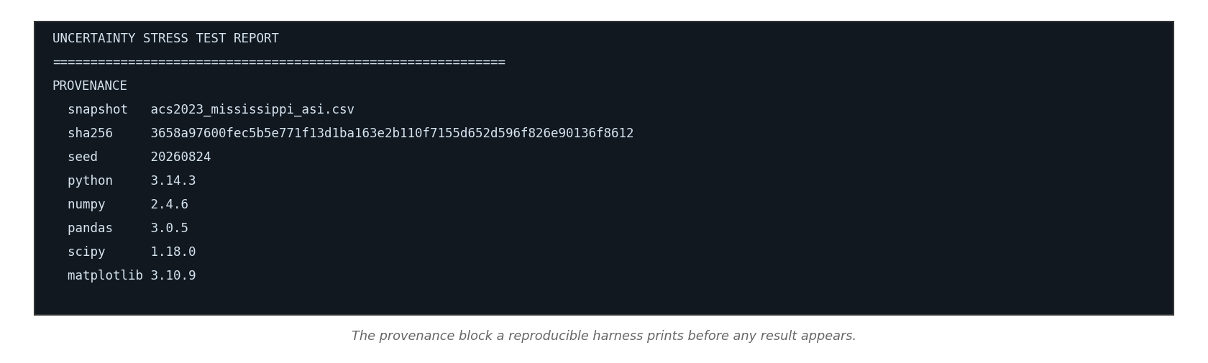
Screenshot. The harness provenance block as printed, showing the checksum, the seed and the package versions.
Step 3: Sweep what matters (Tier 1)
Run the pipeline across the parameter grid the earlier lab identified as consequential. Record the result under each combination and the decision stability across them.
Step 4: Report the four measurements (Tier 1)
Record decision stability, the reliability screen count, cross validated error where a model is fitted, and the Monte Carlo spread where the pipeline propagates margins of error. Those four state how much the result can be trusted.
Step 5: Prove reproducibility (Tier 1)
Type python harness_template.py --twice, which writes the report two times and compares the files byte for byte, then submit both reports with the comparison. If they differ, find the unpinned source and name it in writing.
Step 6: Write the model card (Tier 1)
Produce a one page card stating what the pipeline does, what data it consumes, what it was tested on, the four measurements, and where it fails.
VI-A.3 Lab VI-A Data Package
The data package for this lab consists of 3 files, each already frozen in the snapshots folder of the companion repository and each drawn from the United States Census Bureau, which publishes without registration or a key. The snapshot carries a SHA256 checksum recorded in its manifest, and the program for this lab prints that checksum on every run so a student can confirm the data matches the data the expected values came from. Nothing in the lab touches the network once the snapshot exists, which lets the analysis reproduce offline and years after the original source has changed. The table below lists each file, what it holds and how large it is.
File | Contents | Size
acs2023_mississippi_asi.csv | American Community Survey 2023 five year estimates for Mississippi at county, tract, block group and ZCTA level | 3,832 rows
manifest.json | Row count, vintage and SHA256 checksum of the Census snapshot | 1 record
acs2023_mississippi_moe.csv | Margins of error for the count tables behind the need index | 3,405 rows

Lab VI-B. The Assurance Case and the Person Across the Table
Learning Objectives
Assemble measured evidence from completed labs into an uncertainty register
Derive graduated limits on the system's authority from measured failures
Classify the entries of an unaided assessment as supported, unsupported or unfalsifiable
Defend a decision memorandum aloud to a person acting as the decision maker
Required Software Tools and Setup
A word processor
Any artificial intelligence assistant, required for Step 5
This lab requires no program. A word processor and access to an assistant are sufficient.
Lab at a Glance
Textbook sections | sections 8.14, 15.3, 15.4.3, 15.17, 15.18, 16.6, 16.8, 16.12, 16.17
Technical demand | Tier 1 only. No programming
Effort | three hours plus a live session
Prerequisites | the whole term

VI-B.1 Lab VI-B Overview
Section 15.17 specifies a GeoAI Uncertainty Assurance Case, and Chapter 16 develops governance for a system that has become institutional. This lab produces the assurance artifacts and then tests them against a person, because a governance document is finally a thing somebody signs and defends.
Students produce an uncertainty register in the sense of section 15.4.3, in which every entry names the uncertain element, the affected geography, the expected consequence, the measurement that supports the concern by lab number and value, the mitigation, an owner, a review date and the conditions that would require escalation, and a limits of authority section derived entirely from their own results. They then write a one page decision memorandum to a named role. The lab closes with a tabletop in which another student takes the decision maker role and interrogates the memorandum, asking what it omits and where each number came from. Section 15.18 asks who decides how much uncertainty is acceptable, and the tabletop is where a student discovers that the answer is a person with authority and limited patience.
VI-B.2 Lab VI-B Step-by-Step Instructions
Step 1: Assemble the evidence (Tier 1)
Collect every measured value from the labs you completed, with its lab number, and mark which of the four measurements each one supplies where one applies: decision stability, the reliability screen count, cross validated error or the Monte Carlo spread.
Step 2: Build the register (Tier 1)
Arrange the register under the seven layers of the assurance case in Figure 15.5, being mission claim, evidence quality, spatial robustness, model performance, human challenge, operational resilience, and lifecycle monitoring and learning. Every entry cites one of your measurements. Entries you cannot support with a measurement get flagged as unsupported and stay in, marked, and every residual risk names the role that owns it, as section 15.17 requires.
Step 3: State the limits of authority (Tier 1)
Name the role the system should drop to under Table 16.6.1 for each measured failure, from advisory through restricted and degraded to suspended, and cite the measurement that triggers the change.
Step 4: Write the memorandum (Tier 1)
One page to a named role, stating the recommendation, the evidence and what the analysis cannot support. Include each element of a GeoAI Decision Record in section 16.12 that applies to your system.
Step 5: Generate the counterfeit (Tier 1)
Ask an assistant to write an uncertainty register for your system with no measurements supplied. Mark every entry in what it returns as supported, unsupported or unfalsifiable, and count each category.
Figure withheld from this edition. This figure prints values the lab asks you to find, so it appears only in the instructor edition. Your own run of the lab's program produces the numbers it summarizes.
Figure. The assistant's unaided register beside the student's measured register, entry by entry, with each entry marked supported, unsupported or unfalsifiable.
Step 6: Defend it live (Tier 1)
Present the memorandum to a classmate acting as the decision maker, without notes, and answer what it does not say and where the numbers came from. The decision maker asks at least one question under each of commitments 4, 5, 8 and 10 of the Governance Charter in Table 16.17.1.
VI-B.3 Lab VI-B Data Package
This lab consumes no new data. Its evidence comes from the handoff packages and check value files the student produced in earlier labs, which is the point of the lab, since every entry in the register it builds has to trace to a number the student measured personally. A student who completed few earlier labs will find the register short, and a short register honestly built is the correct result in that case.

